Name ---------------------- Date

Eggs&Dairy
Chapter 9: Breakfast Foods

Use this Study Guide to take notes during class or as you read the section in the textbook.

Parts of an Egg
1.

2.

3.

Grades of Eggs and Their Uses
1.

2.

3.

-•ci
•
l<l
Forms of Eggs and How to Store
1.

'0
;;: 2.
"

:I:
•0
"c'
0.
c
0

E
.1'
•m
:c
••
:0
0
0.
E"
c
0
3.

4.

:g
0
0
'0
"c'

0
E
0•.
@
(CONTINUES ON NEXT PAGE)
Lab Resources & Study Guide r. 147

Study Guide 9.1 (CONTINUED)

Ways to Cook Eggs in Their Shells
1.

2.

3.

4.

Ways to Cook Eggs out of Their Shells
1.

2·------------ ------------------------------------------------

3.

4·-------------------------- -----------------------------

5·-------------- -----------------------------------------

6·-------- ----------------------------------------------- z

Types of Fried Eggs
1.

2.

Doneness of Fried Eggs
1.

2.

3·-------------------- -----------------------
(CONTINUES ON NEXT PAGE)

148 /is;. Introduction to Culinary Arts

Study Guide 9.1 (coNTINUED)

T,,ypes of Omelets with Descriptions

2.

Examples of Egg Safety Tips

1·------------------------------------------------ ------------

2.

3·---------------------------------------------------- --

4.

5.

6.

.,;

l'l

".:r.:
e"

Categories of Dairy Products and Examples

1·--------------------------------------------------------------------

2.

0
Jl

3.

(CONTINUES ON NEXT PAGE)

Lab Resources & Study Guide (/11. 149

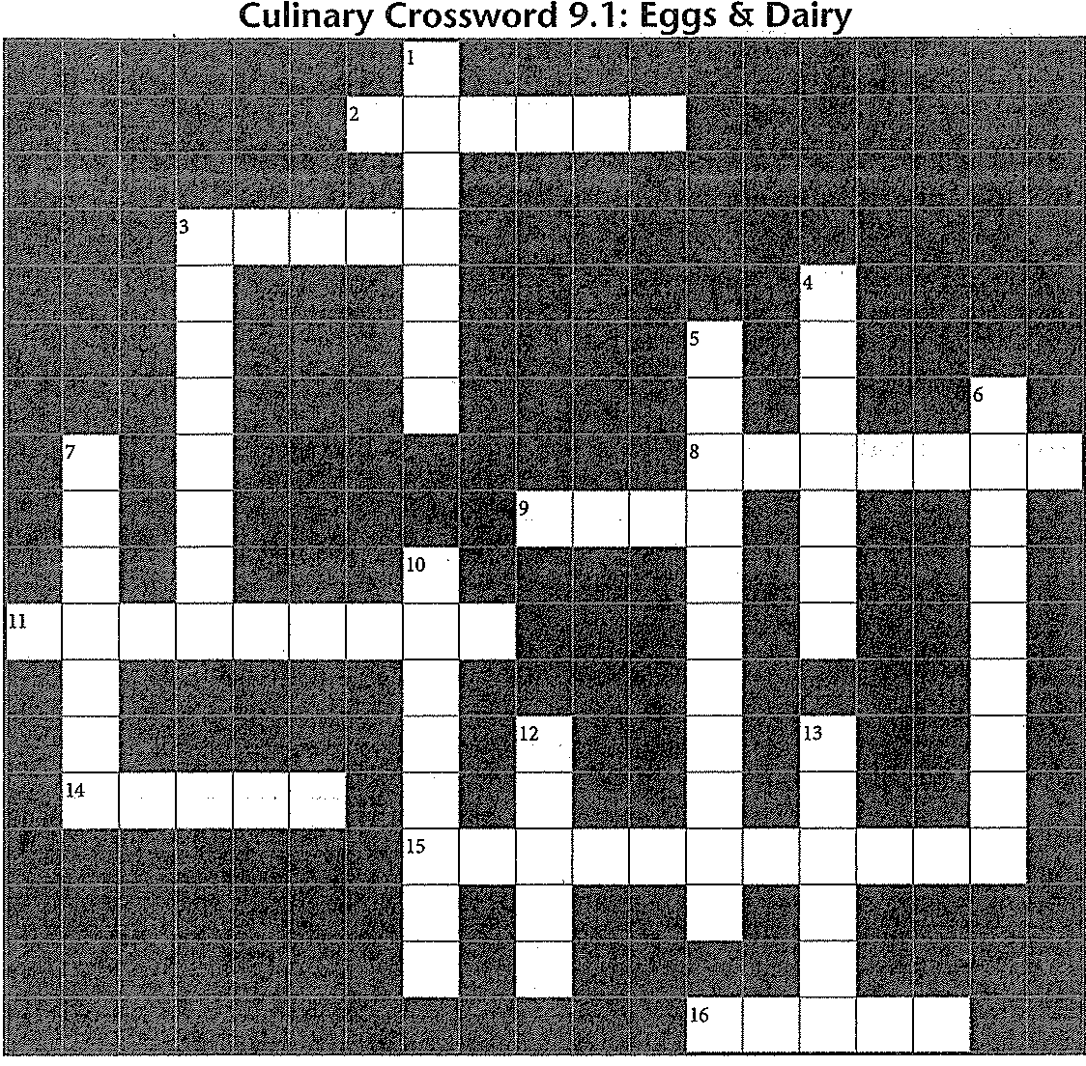Name Date ----------

Use the clues below to solve the puzzle, which contains vocabulary terms from Section 9.1.

Across
2. A French omelet is a type of omelet
3. Sunny-side-up is a type of egg
8. Puffed egg dish baked in a ceramic dish
9. A -cooked egg is served in an egg cup
11. To make eggs, mix the whites and yolks and stir them as they cook in a pan
14. Type of eggs that are in powdered form
15. Milk is to evenly distribute and emulsify fat particles
16. Hard outer casing of an egg

Answers are in the Crossword Solutions section.

150 r. Introduction to Culinary Arts
Down
1. eggs have warm, thickened whites and warm runny yolks
3. Round, open-face omelet that you finish
cooking in the oven
4. Egg white, made up of protein and water
5. Milk and bulk eggs are to kill bacteria and other pathogens
6. Type of butter you can use as a cooking fat at
high temperatures
7. --. eggs are cooked in hot water out of their shells until the whites set and the yolks thicken
10. Natural emulsifier in egg yolk
12. The largest egg size
13. Baked egg dish poured into a crust and baked

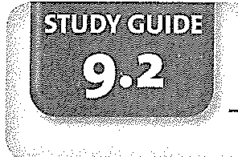Name ----------------------Date

Chapter 9: Breakfast Foods
Breakfast Foods & Drinks

Use this Study Guide to take notes during class or as you read the section in the textbook.

Cooked Breakfast Foods
1. _

2.

3.

4.

Breakfast Breads
1.

2.

3.

4.

5.

6·---------------------------------------------------- -- z

8.

Breakfast Meats and Potatoes
1.

:.= 2.
c

"0'
-"
c
0
'"
ro
u
0
'U (CONTINUES ON NEXT PAGE)
w
c
0
ro
&:
@ Lab Resources & Study Guide 151

Study Guide 9.2 (coNTINUED)

3·------------------------------------------------ -------

4.

$.

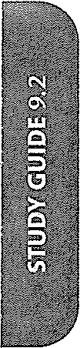6.

Breakfast Beverages

1.

2.

3.

4.

(CONTINUES ON NEXT PAGE)

152 /11. Introduction to Culinary Arts

Name Dme

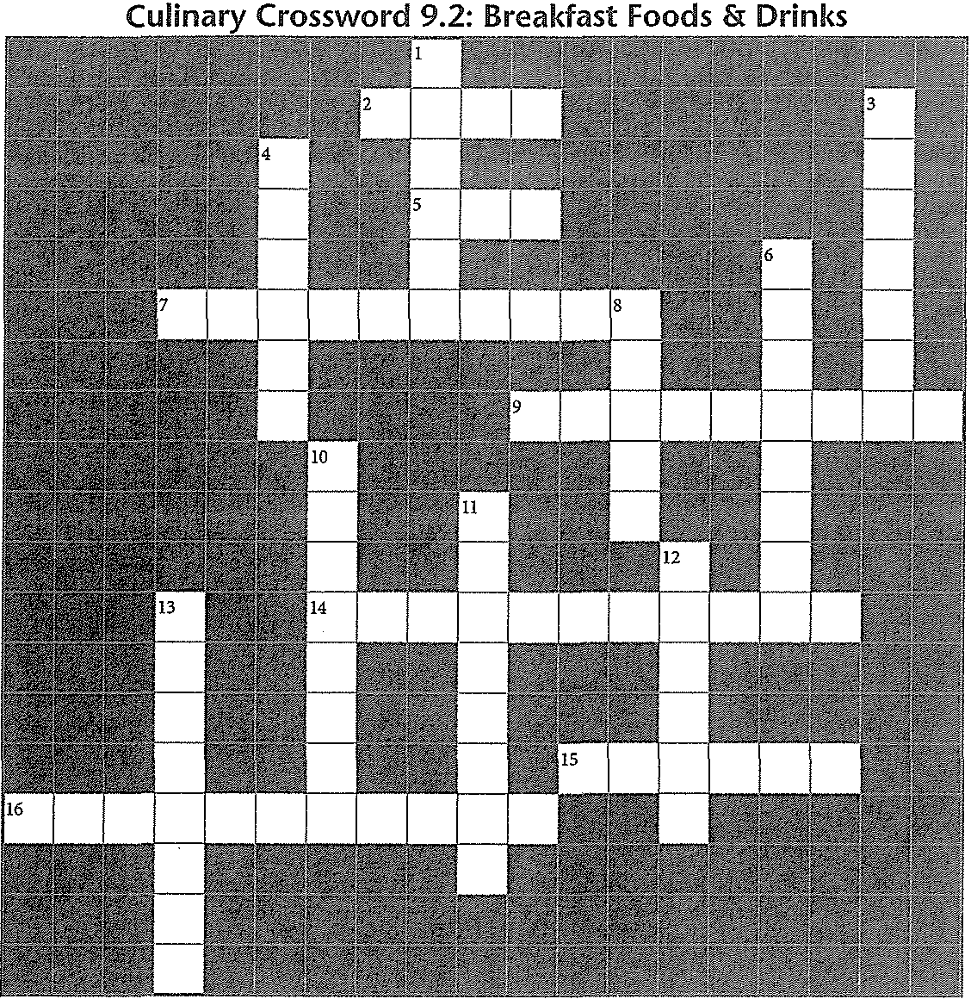
Use the clues below to solve the puzzle, which contains many vocabulary terms from Section 9.2.

Across
2. Chopped meat, potatoes, and seasonings pan­
fried and served with eggs
5. Hot beverage made from steeped leaves
7. Finely chopped potatoes, pressed down in a pan and browned on both sides (2 words)
9. Buttery crescent-shaped roll
14. Piece of bread dipped in mille and egg mixture and then fried (2 words)
15. Paper-thin French pancakes
16. Type ofbreakfast that includes bread, hot beverage, and juice
Down
1. Wet form of dough used for pancakes
3. -fried steak is dipped into an egg-milk mixture, fried, and topped with gravy
4. Swiss version of granola
6. Breakfast meats available as patties or links
8. Rich biscuit that sometimes contains raisins
10. Chemical stimulant found in many beverages
11. Type of bacon that is lean and similar to ham
12. Popular beverage made from ground beans
13. Cold, thick drink made by blending fresh fruit, juice, and ice

Answers are in the Crossword Solutions section.

Lab Resources & Study Guide j;,. 153

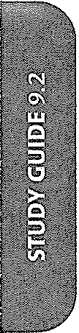

154 /1;;. Introduction to Culinary Arts

Name ---------------------Date

Dressings & Dips
Chapter 10: Garde Manger

Use this Study Guide to take notes during class or as you read the section in the textbook.

G,,arde Manger General Responsibilities
2.

3.

4.

Basic Types of Vinaigrettes
1.

2.

Ingredients in Vinaigrettes
1. _

2.

3.

4.

5.

6.
z

8.

Uses for Vinaigrettes
1.

2.

3.

4.

5.

6.

(CONTINUES ON NEXT PAGE)

Lab Resources & Study Guide 1/J». 155

Study Guide 10.1 (coNTINUED)

Ingredients in Mayonnaise
1.

2·---------------------------------------- --------------------
3.

4·---------------------------------------------- --------

Tips on Making Mayonnaise
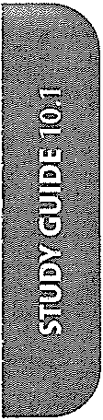1.

2.

3.

4.

Mayonnaise Dressings and Dips and Their Uses
1.

2.

3.

4.

Ingredients in Dairy-Based Dressings and Dips
1.

2.

3.

(CONTINUES ON NEXT PAGE)

156 fi;,. Introduction to Culinary Arts

."E
2
0
·
w"
"
c
0
ro
o"'
@

Study Guide 10.1 (CONTINUED)

Ingredients/Uses for Cooked Dressings and Dips
1.

2.

3·---------------------------------- --------------------

4.

Vegetable- and Fruit-Based Dressings and Dips
1.

2.

3.

4.

(CONTINUES ON NEXT PAGE)

Lab Resources & Study Guide /Jb. 157

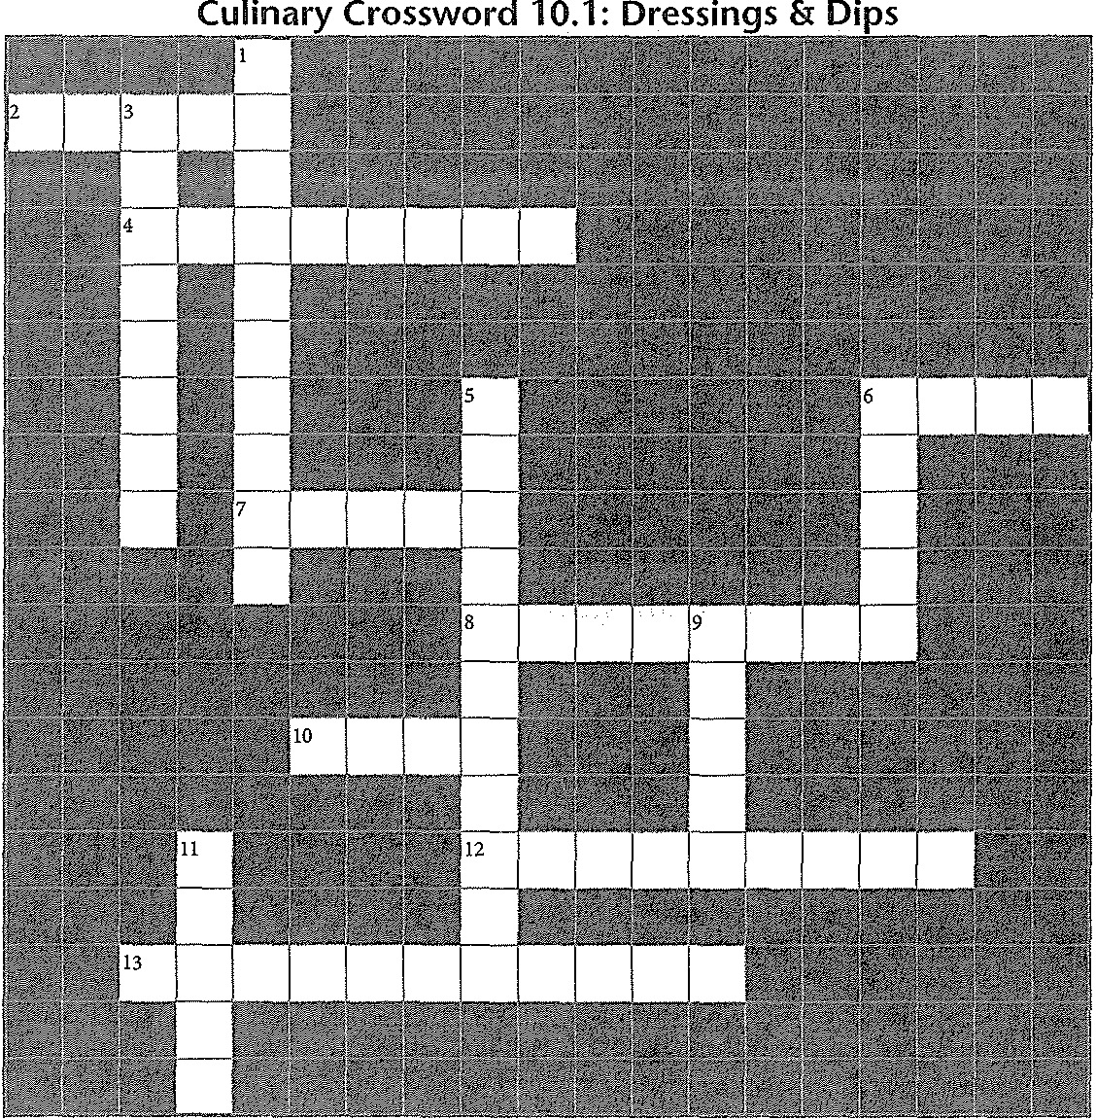Name ----------------------Date

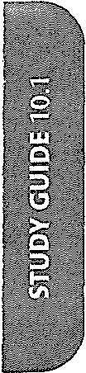

Use the clues below to solve the puzzle, which contains many vocabulary terms from Section 10.1.

Across
2. -virgin olive oil, a fine grade of oil
4. Herbes de , a dried herb mixture used in salad dressings
6. Sauces served with chips or raw vegetables
7. Often used in a dressing to temper the vinegar's acidity
8. Mixture of uniform consistency, such as oil and vinegar blended together
10. ghanoush, Middle Eastern eggplant
spread
12. Mexican dip made of avocados
13. Salad dressing made of oil and vinegar

Answers are in the Crossword Solutions section.

158 IJI;. Introduction to Culinary Arts
Down
1. Thick, creamy blend of oil and egg yolks
3. French dip made of black olives
5. Person in the kitchen responsible for cold food preparation (2 words)
6. Type of mustard commonly used in salad dressings
9. Flavorful and usually spicy tomato dressing
11. Tool often used to blend salad dressing ingredients by hand

Name Date

Salads
Chapter 10: Garde Manger

Use this Study Guide to take notes during class or as you read the section in the textbook.

,P,urposes of Salads and Their Characteristics

2.

3. ------------------------------------------------------

4.

5·------------------------------------------------------

T,,ypes of Salad Greens and Examples

2.

"J:
3.

•u

a.
c
./Review the pictures and descriptions of salad greens. Be able to identify the following:
It

"• Iceberg Lettuce
0>
c
:0
Radicchio
Mizuna
Dandelion

·:0"
Boston Lettuce Arugula
Mustard Leaves
Escarole

"0.
J
Bibb Lettuce
Frisee
Watercress
Red Leaf Lettuce

E
"0
'w"
c
0
E•
It
@
Romaine Lettuce Mache Belgian Endive Baby Spinach

(CONTINUES ON NEXT PAGE)

Lab Resources & Study Guide /IJI;. 159

Study Guide 10.2 (CONTINUED)

F,.resh Herbs in Salads
2.

3.

4.

5.

6.

T,.ips on Preparing Greens
2.

3.

4.

5.

G,.arnishes for Green Salads

2·------------------------------ ------------------------
3.

4.

5.

Raw or Cooked Vegetables in Salads
1.

2·-------------------------------------------------- ----
3.

4.

5.

S,.tarches in Salads

2.

3.

4·-------------------(C-ONTINUES ON NEXT-PA-GE-) -------------------­

160 Introduction to Culinary Arts

Study Guide 10.2 (coNTINUED)

Protein in Salads

1·-------- -----------------------------------------------
2.

3.

4·-------------------------------------- -----------------
5.

Fruit and Nuts in Salads
1.

2.

3.

Components of a Composed Salad
!.

2.

3.

4.

Guidelines for Preparing a Composed Salad
!.

2.

3.
l 4.
•"

·"'

"•0'

c
Composed Salad Examples and Ingredients
1.

2.

!i!
ro
&:

"ro
"c'
:2
·:c"
3.

4.

c
0
·,
(CONTINUES ON NEXT PAGE)
"
w
c
0

@ Lab Resources & Study Guide i/JI;, 161

ne Date. _

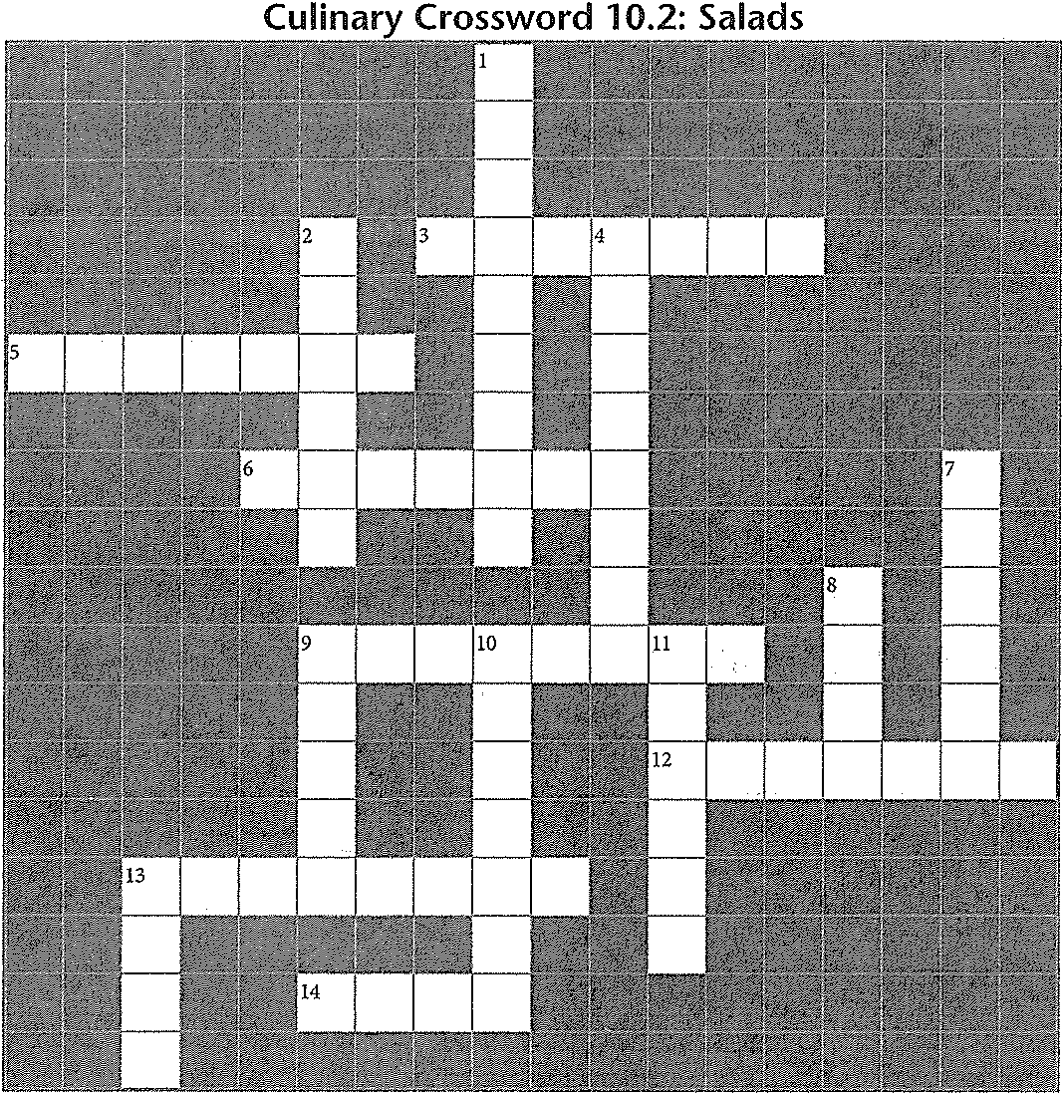

)55
French-style mix of salad greens
French salad of tuna, olives, egg, and green beans
salad often features fruit or gelatin and
is served with a sweet dressing
Type of salad with artfully arranged
. ingredients
Popular type oflettuce that comes in a tight head
Ingredients you can add to salads, including bread, grains, or pasta
-course salad, a balanced meal
containing protein

lnswers are in the Crossword Solutions section.

1J1> Introduction to Culinary Arts
Down
1. Type of salad served before the main course
2. salad means the ingredients are combined with dressing
4. Crisp bread cubes used as a salad garnish
7. Category of salad greens that includes dandelion and chicory
8. Popular salad with sliced turkey or chicken, avocado, cheese, eggs, and bacon
9. Bell pepper and radicchio add this to a salad
10. Meat, poultry, or cheese contribute this to a salad
11. Type of flowers, such as pansies and violets, added to salads for extra appeal
13. Type of salad served with the main dish

Name ------------------------------ -------------- Dme

Cheese
Chapter 10: Garde Manger

Use this Study Guide to take notes during class or as yon read the section in the textbook.

Basic Cheese Types, Characteristics, and Examples

1.

2.

3.

4.

5.

6·------------------------------------------------------------------------
•
."l
·0.>:
z

Tips on Buying Cheese

1.

2.

(CONTINUES ON NEXT PAGE)

Lab Resources & Study Guide !J,.. 163

Study Guide 10.3 (CONTINUED)

3.

4.

Tips on Handling Cheese

1.

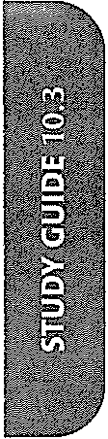2.

3.

4.

$.

6.

T,.ips on Storing Cheese

2.

3·-------------------------------------------------- -----

(CONTINUES ON NEXT PAGE)

164 ,. Introduction to Culinary Arts

Study Guide 10.3 (CONTINUED)

Tips on Serving Cheese
1.

2.

3.

How to Serve Cheese within a Formal Meal
1.

2.

How to Present Cheese for Service
1.

2.

3·---------------------------------------------------- ---

4.

:c
"
•u
Using Cheese in Cooking
c ,.
a.
,::
"ro
0>
c
:o 2·------------------------------------------------------------ ------
0
"-
J
E
c' 3.
u
-a
w
c
0· (CONTINUES ON NEXT PAGE)
"
@ Lab Resources & Study Guide 165

Name

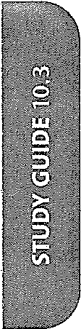

Across
Dme

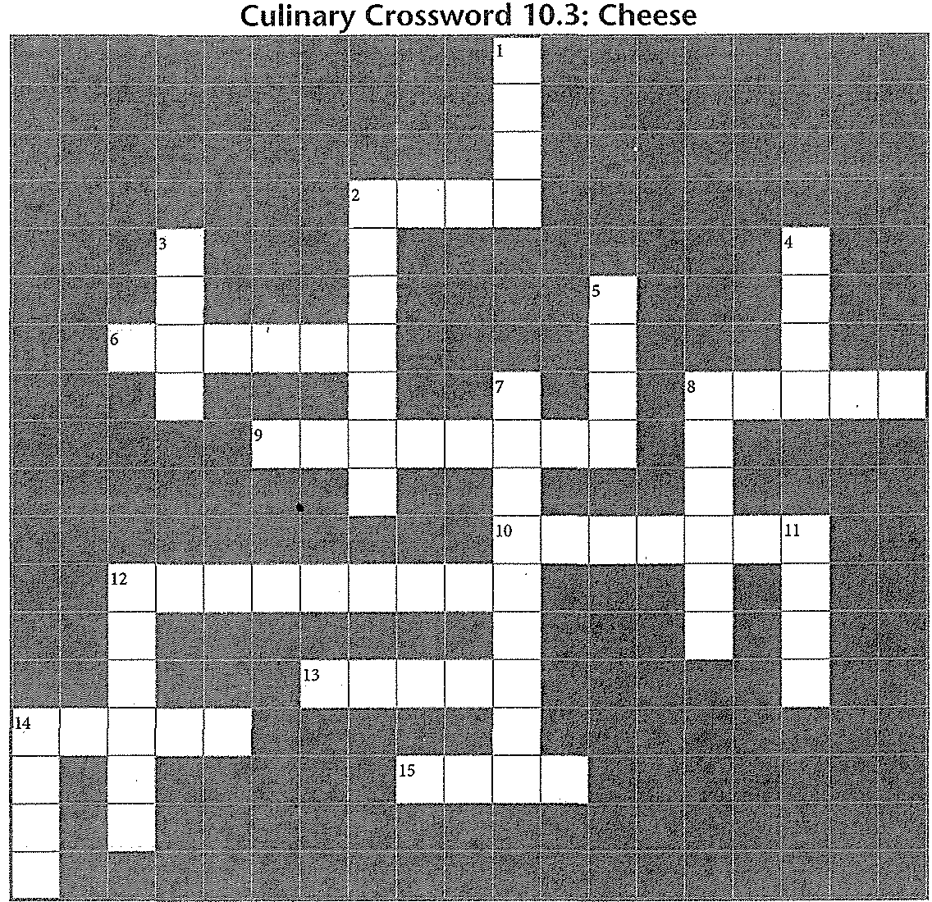Use the clues below to solve the puzzle, which contains many vocabulary terms from Section 10.3.

Down

2. Type of cheese, also called chevre
6. of cheeses is a cheese course with multiple items
8. Feta and ricotta are examples of cheese
9. jack, example of semi-soft cheese
10. Popular example of hard cheese
12. Italian hard cheese
13. Jarlsberg and Gruyere are -style cheeses
14. Cheese is sometimes served on a platter called a cheese
15. Type of salad served with the main dish

Answers are in the Crossword Solutions section.

166 {IP> Introduction to Culinary Arts
1. ·Cheese is sometimes served from a cheese' at a restaurant
2. Parmigiano-Reggiano is ideal for this
3. Substance that makes blue veins in cheese
4. Popular example of soft, rind-ripened cheese
5. When making cheese, the milk coagulates and separates into curds and _
7. Type of cheese made from finely ground cheese that is heated and poured into a mold
8. Melted cheese dish
11. Surface of an aged cheese
12. Grana , type ofltalian cheese
14. Gorgonzola is an example of this type of cheese

Name ----------------------Date

Chapter 10: Garde Manger
Cold Food Presentation

Use this Study Guide to take notes during class or as you read the section in the textbook.

T,.ypes of Cold Food Presentations and Examples

2.

3.

4.

-ci
5.

l<l

'0

Tips on Buying Shellfish
,.

2.

3.

(CONTINUES ON NEXT PAGE)
Lab Resources & Study Guide /Itt. 167

tudy Guide 10.4 (coNTINUED)

·ips on Handling and Serving Caviar

' -----------------------------------------------------------------
'·------ ------------------------------------------------------------
k _

'·--------------------------------------------------------------------
··--------------------------------------------------------------------
)esign Elements for Food Arrangements
!.

------------------------------

3.

4.

5.

6.

z --

Tips for Buffet Table Design
1.

2.

3.
------

4.

(CONTINUES ON NEXT PAGE)

Study Guide 10.4 (CONTINUED)

Two Ways to Serve the Main Item in a Cold Food Presentation
1.

2.

Serving Tools for Cold Food Presentations
1.

2.

3.

4.

5.

Tips for Centerpieces
1.

2.

3.

Guidelines for Garnishing
1.

2.

3.

4.

5.

6.

(CONTINUES ON NEXT PAGE)

Lab Resources & Study Guide .). 169

Name -----------------------Date

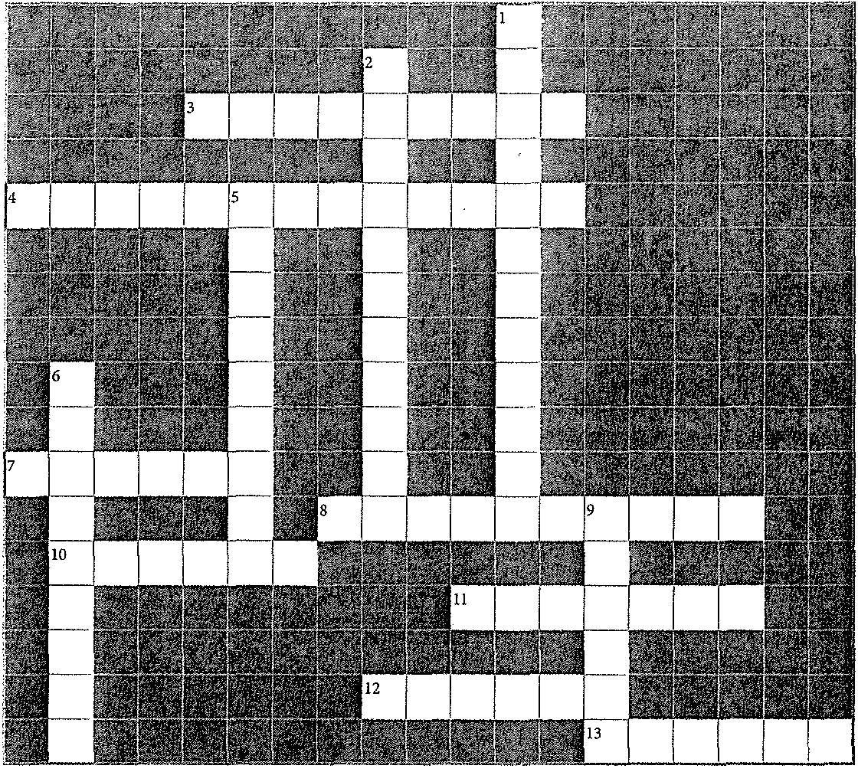Culinary Crossword 10.4: Cold Food Presentation

Use the clues below to solve the puzzle, which contains many vocabulary terms from Section 10.4.

Across
3. Describes shellfish placed in fresh water to purge them of impurities and sand
4. Dip for shrimp and other seafood, made of
ketchup and horseradish (2 words)
7. Thin Rnssian crepes
8. Arranging slices of meat to overlap one another in the order they were cut
!0. Type of smoked fish that is often served in cold food presentations
11. Swedish cured salmon
12. Fish eggs from the largest sturgeon
13. Counter where fresh, uncooked shellfish is served (2 words)

Answers are in the Crossword Solutions section.

170 .). Introduction to Culinary Arts
Down
1. Example of an elaborate, frozen centerpiece
(2 words)
2. Style of serving a main item, where a large part of it is left unsliced (2 words)
5. Platter of assorted cured meats, cheeses, and pickled vegetables
6. Clams and oysters are often opened and served on the (2 words)
9. Salted fish eggs

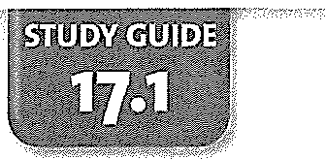Name --------------------Date _

Chapter 17: Yeast Breads, Rolls, & Pastries
Introduction to Baking

Use this Study Guide to take notes during class or as you read the section in the textbook.

Types of Flour Used in Baking
1.

2.

3.

4.

Tips on Storing Flour
1.

2.

3.

4.

How Eggs are Used in Baking
1.

2.

3.

4.

5.

6.

Safety Tips for Using Eggs in Baking
1.

2.

3.

4.

Types of leaveners Used in Baking
1. _

2.

3.

(CONTINUES ON NEXT PAGE)

Lab Resources & Study Guide /Jll;. 227

Study Guide 17.1 (continued)

What Fat Contributes to Baked Goods
1. I

2.

3.

Types of Fats and Examples
1.

2.

Sweeteners Used in Baking

1. 5. -----------------------------

2. 6. -----------------------------

3. 7. ----------------------------

4. 8. ----------------------------

Acids Used in Baking

1.
4. _

2. 5. -----------------------------

3. 6. -----------------------------

Thickeners Used in Baking
1.

2.

3·---------------- ---------------------------------------
4.

5.

Measuring Tools Used in Baking
1.

2.

3.

4.

5.

(CONTINUES ON NEXT PAGE)

228 II;. Introduction to Culinary Arts

Name De

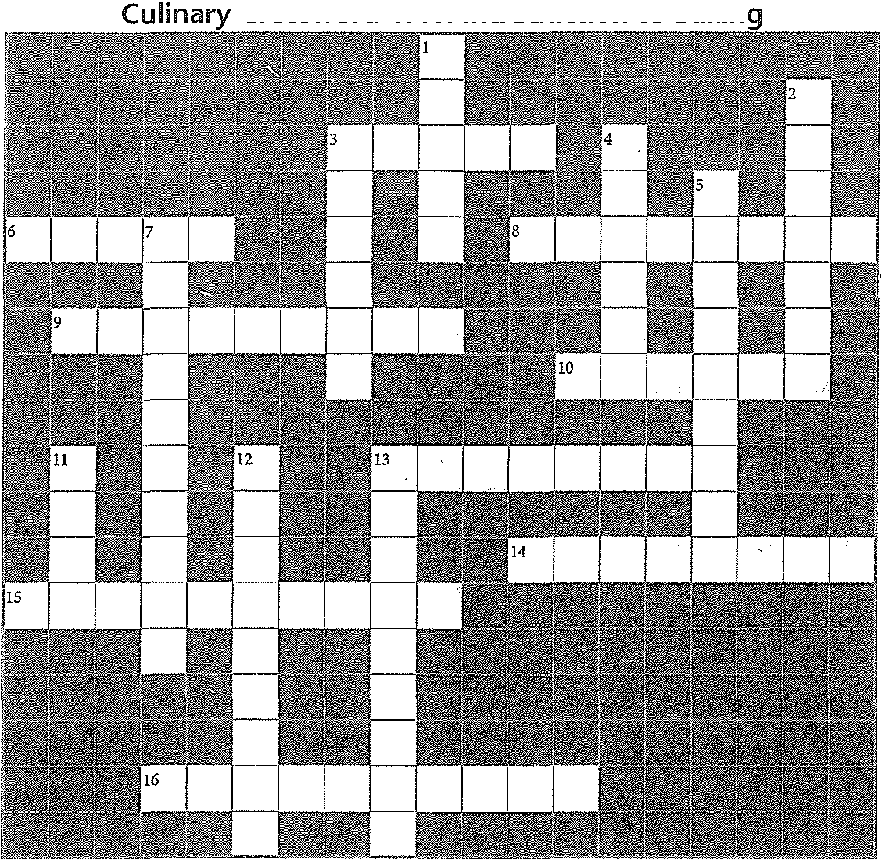Crossword 17.1: Introduction to Bakin

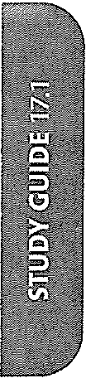

Across
Use the clues below to solve the puzzle, which contains vocabulmy terms from Section 17.1.

Down

3. Type of flour that is considered "harder" than all-purpose flour
6. Tiny, single-celled organism that increases the volume of dough
8. What bakers often call their recipes
9. Heatproof paper used in baking to line pans
10. Thickener found in apples and citrus fruit
13. Pastry tool with teeth, used to give icing a decorative finish (2 words)
14. It increases the volume of dough by adding air
15. Solid fat that lacks flavor but adds extraordinary flakiness to baked goods
16. Changing the structure of proteins, as acids do to baked goods

230 IJi., Introduction to Culinary Arts
1. To work moistened flour by hand
2. Thickener made from animal byproducts
3. Solid fat that adds flavor and flakiness to baked goods
4. Work surface excellent for cooling dough
5. Used to spin a cake with one hand while you decorate it with the other hand
7. Type of pan with a removable base, used to make delicate cakes
11. Egg , a mixture of egg and water that you brush on top ofbread before baking
12. Type of sugar also referred to as baker's sugar
13. Thick liquid sweetener, available as light or dark (2 words)

Answers are in the Crossword Solutions section.

0
E
..c,'
0
ro
u
0
'0
w
c
0
i"
@

Study Guide 17.1 (continued)

Common Work Surfaces Used in Baking
1.

--------

2.

Cutting Tools Used in Baking

1.
2.

3. .-----------------------------------------------

Bread-Baking Equipment

1.
2.

Appliances Used in Baking
1. 3.

2. 4. ------------------------

liners, Baking Pans, and Molds
1. 6.

2. 7. -------------------- ---------

3. 8. --------------------,-------
4. 9.

5. 10.
,;

Pastry Tools

1.
5. _

2. 6.

3. 7. ----------------------
4. _

Examples of Ingredients Used in Formulas
1. 6.
2. z
J
E
3. 8. -----------------------
4. 9.

5. 10. ------------------------
ro (CONTINUES ON NEXT PAGE)
<1'
@! Lab Resources & Study Guide

229

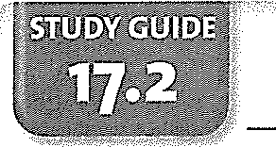Name ---------------------- Date

Yeast Dough
Chapter 17: Yeast Breads, RoUs, & Pastries

Use this Study Guide to take notes during class or as you read the section in the textbook.

Types of Yeast Dough, Ingredients, and Examples of Products
1.

2·---------------------- --------------------------------------

3.

Steps in Straight Dough-Mixing Method
1.

-•ci
•ID

J:l

2.

m
·c
<( 3.
"
I
•0
-
0. 4.
c
0
E
0
d"
ID
0 5.
m
c
:E
·:0"
0
0.
J 6.
E
c'
0
"
0
0

-o
w
c
0
E
0
0•.
@
(CONTINUES ON NEXT PAGE)

Lab Resources & Study Guide /Ill» 231

Study Guide 17.2 (continued)

Modified Mixing Method for Making Enriched Yeast Dough

1·------------------------ -------------------------------

2.

3·---------------------------------------------------------- --

4.

5.

Using the Sponge Mixing Method
1.

2.

3.

4.

Using a Pre-Ferment
1.

2.

3.

4.

Types of Pre-Ferments
1.

2.

3.

4.

(CONTINUES ON NEXT PAGE)

232 /JIJ;. Introduction to Culinary Arts

Study Guide 17.2 (continued)

Using Rolled-In Dough
1.

2.

3.

4·--------------------------------------------------------------

Garnishes for Yeast Bread
1.

2·---------,----------------------------------------------------
3.

4.

(CONTINUES ON NEXT PAGE)

0
E
c
·0
u
"
"c'
0
ro
<:
@ Lab Resources & Study Guide iJi,. 233

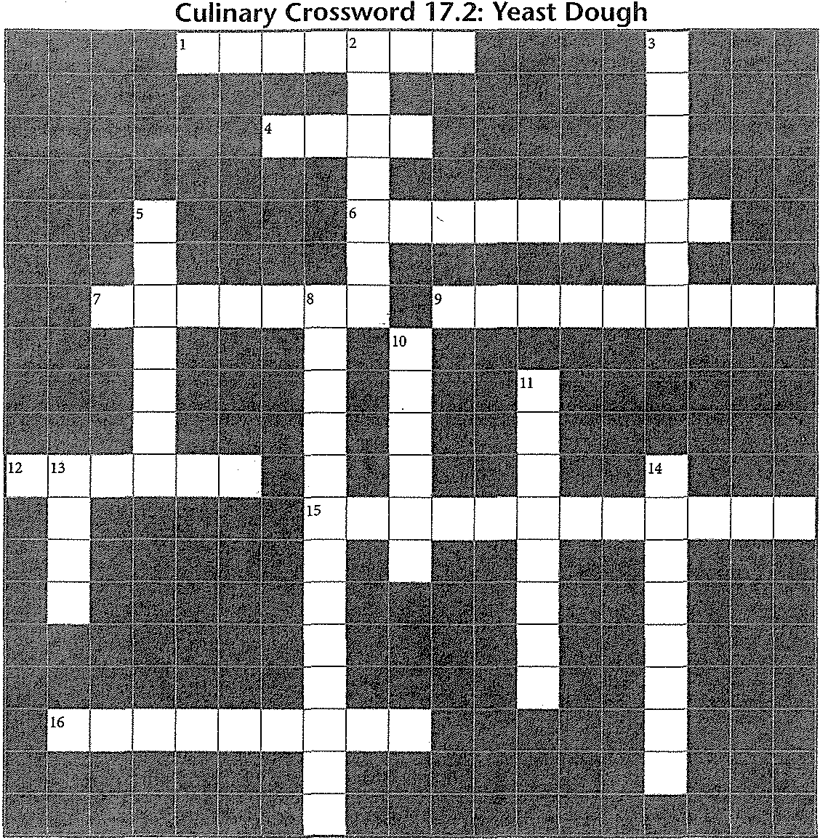Name Dare ----------------------

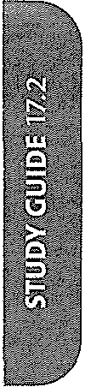

Use the clues below to solve the puzzle, which contains many vocabulary terms from Section 17.2.

Across
1. Rich French bread with a knotted top
4. Pizza crust and hard rolls are made with this type of dough
6. Type of yeast dough made of alternating layers of dough and fat
7. Combine equal parts of flour and water with some yeast to create this
9. Soaking process that activates yeast
12. Mixing method that starts by combining some liquid and flour with all the yeast to make a loose dough
15. Name of test where you check if dough is thin enough for light to come through it (2 words)
16. Starter with a tangy flavor made from wild yeast

234 {1:. Introduction to Culinary Arts
Down
2. Jewish braided holiday bread
3. Pre- , also called a dough starter
5. Traditional Christmas bread filled with dried fruit
8. Mixing method where all ingredients are added at the same time (2 words)
10. First stage of mixing ingredients
11. Delicious sweet bun with raisins and icing, served warm
13. fermentee, a piece of dough saved from another batch
14. Type of dough that is buttery and sweet

Answers are in the Crossword Solutions section.

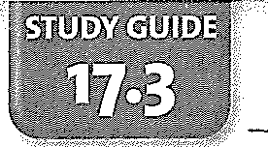Name ---------------------Date _

Chapter 17: Yeast Breads, RoHs, & Pastries
Breads, Rolls, & Pastries

Use this Study Guide to take uotes during class or as you read the section in the textbook.

Steps for Dividing and Pre-Shaping Dough

1·---------------------------- --------------------------------
2.

3.

4. _

5.

6.
z

8.

Bread Shapes and Examples
1.

2.

-•ci
•
l'l
·0c>

3.

1i
4.
:I:
•u
.'§

n.
c
0
0•

n.
•0
0>
c
:"·0"'
0
0.
5.

-"" 6.
c
0

u
0
'0
w
c
0
ro (CONTINUES ON NEXT PAGE)
•
n.
© Lab Resources & Study Guide /JJI> 235

Study Guide 17.3 (continued)

After Shaping/Before Baking Preparation
1.

2.

3.

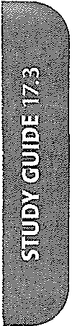Baking Stages
1.

2.

3.

Tips for Cooling and Slicing
1.

2.

3.

4.

Post-Baking Quality Evaluation
1.

2.

3.

(CONTINUES ON NEXT PAGE)

236 Introduction to Culinary Arts

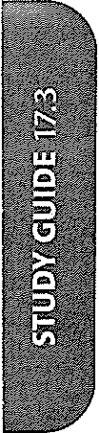

238 /II> Introduction to Culinary Arts

Name Dare

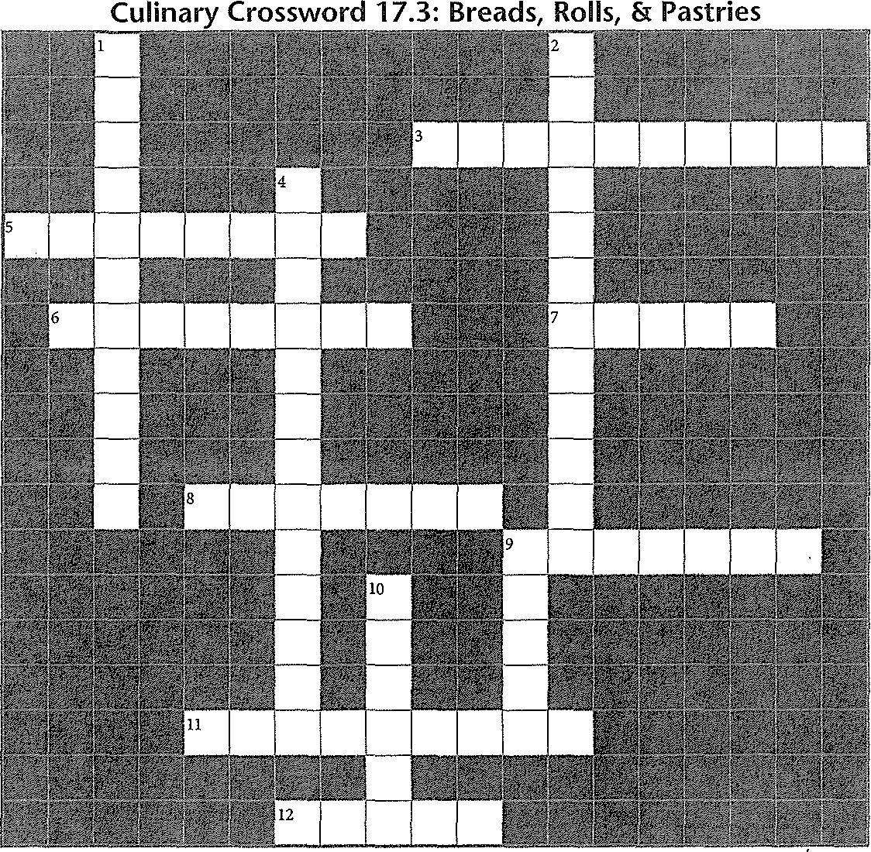Use the clues below to solve the puzzle, which contains many vocabulary terms from Section 17.3.

Across
3. Last stage of rising that occurs in the oven
(2 words)
5. Type of knife best used for slicing bread
6. Italian flat bread
7. What forms on dough's outer surface when it dries out in the oven
8. Cutting the top of dough to release steam
9. Type ofloaf made with three tapered ropes of enriched dough
11. Long, narrow French breads
12. Sugary liquid brushed onto sticky buns before baking
Down
1. Letting dough rise one last time after it is shaped (2 words)
2. Hand tool used to cut dough (2 words)
4. Letting dough rest until you can stretch it without tearing (2 words)
9. French term for round loaf of bread
10. Ethiopian flat bread

Answers are in the Crossword Solutions section.

Lab Resources & Study Guide f/1;;,. 237

Name ---------------------Date ---------

Chapter 18: Quick Breads
Muffins & Quick Breads

Use this Study Guide to take notes during class or as you read the section in the textbook.

Basic Ingredients for Muffins/Quick Breads
1.

2.

3.

4.

5.

6.

z

Mixing Methods
-d 1.

"
:"E
-

"" 2.
•u
·g

0.
c
0
ro
8:
Tips on Preparing/Filling Pans and Baking
c
:·E" 1.
:0
"0.
ci
5
2 2.
0
·
"w"0

c
0
ill
0.
@
(CONTINUES ON NEXT PAGE)

Lab Resources & Study Guide fJJ;,. 239

Study Guide 18.1 (continued)

3.------------------------------------------------------

4.

5.

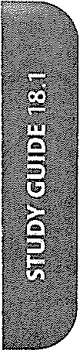Examples of Stir-Ins and Toppings

1·---------------------------------- --------------------
2.

3.

4.

5.

6.
z

8.

Tips for Adding Stir-Ins and Toppings
1.

2.

3.

4.

5.

(CONTINUES ON NEXT PAGE)

240 /iJ,. Introduction to Culinary Arts

Name Dme

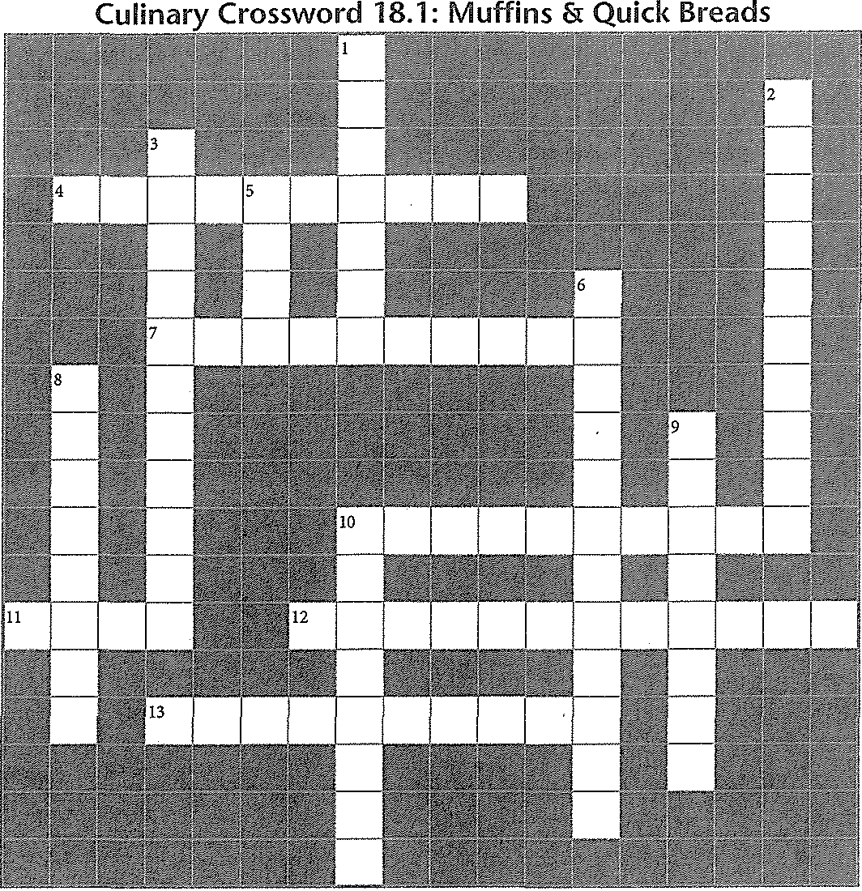

Across
Use the clues below to solve the puzzle, which contains vocabulary terms from Section 18.1.

Down

4. Way of mixing in which a depression is made in flour and liquid is poured in (2 words)
7. Leavener used for.quick breads (2 words)
10. Thin, sweet liquid brushed on top of baked goods to make them glossy (2 words)
11. Muffins are baked in these
12. Mixture of fat, sugar, and flour sprinkled on muffins before baking (2 words)
13. Type of sugar that adds texture to quick breads and muffins.O
1. scooper is used to make muffins all the same size
2. Type of flour most often used for muffins and
quick breads (2 words)
3. Common fruit stir-ins for muffins
5. Liquid commonly added to muffins and quick breads
6. This leavener can be "double acting" (2 words)
8. Mixing sugar and fat vigorously to add air
9. Quick breads are usually baked in these
(2 words)
10. Mixture of fat, sugar, flour, spices, and nuts sprinkled on muffins before baking

Answers are in the Crossword Solutio11s section.

Lab Resources & Study Guide 241

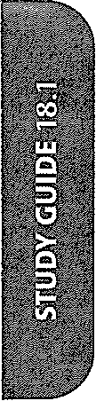

242 fl., Introduction to Culinary Arts

Name -------------------------Date ---------

Biscuits & Scones
Chapter 18: Quick Breads

Use this Study Guide to take notes during class or as you read the section in the textbook.

Types of Biscuits
,.

2.

3.

-•ci

.g
T,,ypes/Shapes of Scones
2.

3.

4.

I,.ngredients in Soda Bread

2.

3. -------------------------------------
4.

B,.aking Temperature Tips

2.

3.

4.

(CONTINUES ON NEXT PAGE)
Lab Resources & Study Guide .. 243

Study Guide 18.2 (continued)

Basic Shaping Tips
1.

2.

3.

4.

5.

6.

Serving Options
1.

2.

3.

4.

5.

(CONTINUES ON NEXT PAGE)

244 fli, Introduction to Culinary Arts

c'
0
·
0 "w0 c
0

81
@

Name Drue

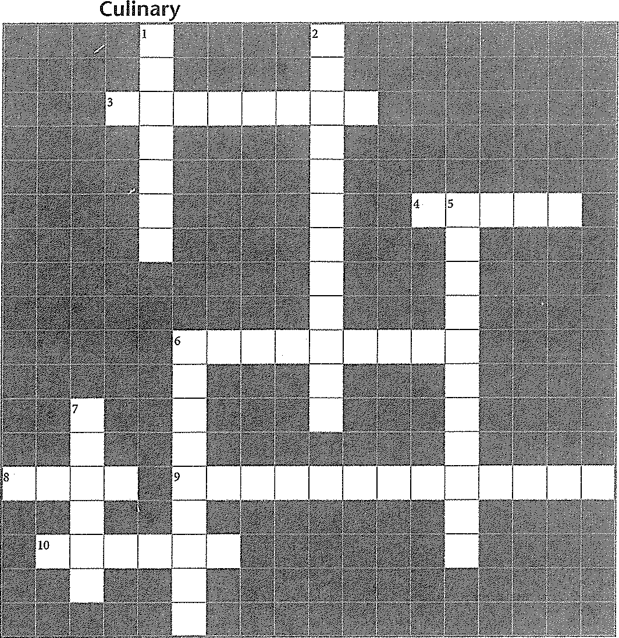Crossword 18.2: Biscuits & Scones

Across
Use the clues below to solve the puzzle, which contains many vocabulary terms from Section 18.2.

Down

3. Small quick breads with little or no sugar
4. Add this liquid to scones to make them richer than regular scones
6. Biscuits are the foundation for this dessert that is topped with whipped cream
8. Type of biscuits made from a liquidy dough that falls from a spoon onto a baking sheet
9. Sharp tool needed to portion dough when making small round quick breads
10. Type of biscuits made from dough that is worked a long time until it is hard
1. Fat should be to keep it from blending too much with flour when making biscuit dough
2. British tradition of serving a light meal of small sandwiches, scones, and cakes before dinner (2 words)
5. Method of mixing fat and flour that is used to make biscuits (2 words)
6. Round baked item made with buttermilk and raisins (2 words)
7. Sweet individual quick breads that may contain fruit or nuts

Answers are in the Crossword Solutions section.

Lab Resources & Study Guide 245

• ju. Introduction to Culinary Arts

Name ----------------------Date

Chocolate
Chapter 19: Desserts

Use this Study Guide to take notes during class or as you read the section in the textbook.
Basic Types of Chocolate
1.

2.

3.

Variations on the Basic Types of Chocolate
1.

2.

3.

4.

•:I:
•0
£
c

5.

6.

7. --------------------------------------------------------

0

0
ro
"c'
:2
·:0"
0
Tips for Melting Chocolate
1.

2.

3.

4. ----------------------------------------------------------------
(CONTINUES ON NEXT PAGE)

Lab Resources & Study Guide fi;. 247

Study Guide 19.1 (continued)

$.

6·---------------------- --------------------------------- z

8.

Tips for Tempering Chocolate
1.

2.

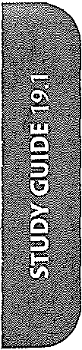3.

4.

$.

6.
z
8.

Tips for Storing Chocolate
1.

2.

3.

4.

Making a Ganache

1·-------------------------------------------------------- ----

2·------------------------------------------------------

3·-------------------------------------------------- ----------

4.

$.

(CONTINUES ON NEXT PAGE)
248 fll> Introduction to Culinary Arts

Name ----------------------- Date

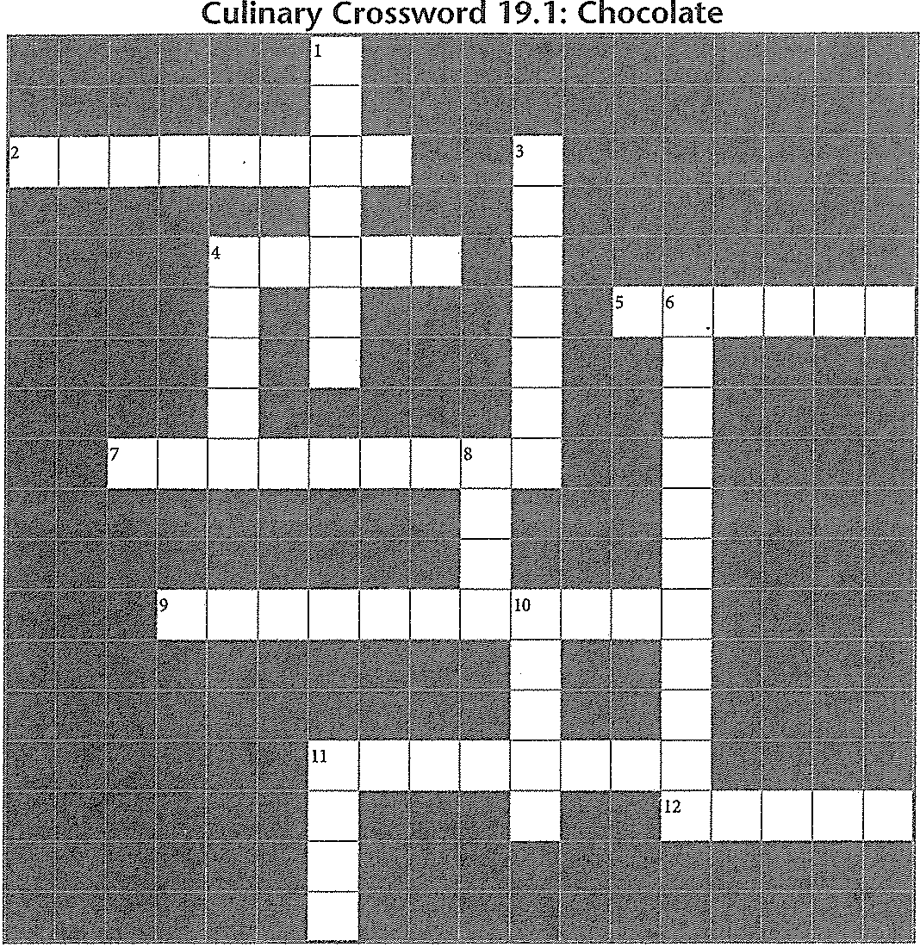

Across
Use the clues below to solve the puzzle, which contains vocabulary terms from Section 19.1.

Down

2. Type of chocolate made with vegetable fat
4. Chocolate comes from this tree
5. Cocoa , the fat from cocoa beans
7. Process of properly crystallizing chocolate
9. Type of chocolate that has less sugar than semisweet chocolate
11. One thing to avoid when storing chocolate
12. Most cocoa powder is processed
1. Emulsion made with chocolate and a liquid
3. Method for cooling chocolate that uses a marble slab
4. Liquid added to chocolate to make truffle centers and candy or cake fillings
6. Baker's chocolate is also called chocolate
8. Cleaned cocoa kernels
10. chocolate contains no chocolate liquor
11. chocolate is sweeter than dark chocolate

Answers are in the Crossword Solutions sectio11.

Lab Resources & Study Guide 249

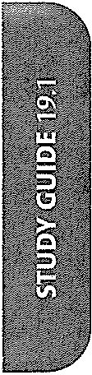

250 /1> Introduction to Culinary Arts

Name ----------------------- Date

Chapter 19: Desserts
Custards, Mousses, & Frozen Desserts

Use this Study Guide to take notes during class or as you read the section in the textbook.

Basic Ingredients of Custard
1. _

2.

3.

Basic Types of Custards and Descriptions
1.

2.

3. _

Components of Mousse
1.

2.

0
"' 3. _
0.
ci
E

o'
0
"ro'
u
0
'0
4.

w
0
0

•ro
©
(CONTINUES ON NEXT PAGE)

Lab Resources & Study Guide 251

Study Guide 19.2 (continued)

Types of Frozen Desserts
1.

2.

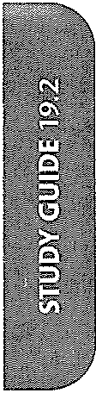3.

4.

$.

Factors that Affect the Hardness of a Frozen Dessert
1.

2.

(CONTINUES ON NEXT PAGE)

252 /JIJ:> Introduction to Culinary Arts

Name
Date

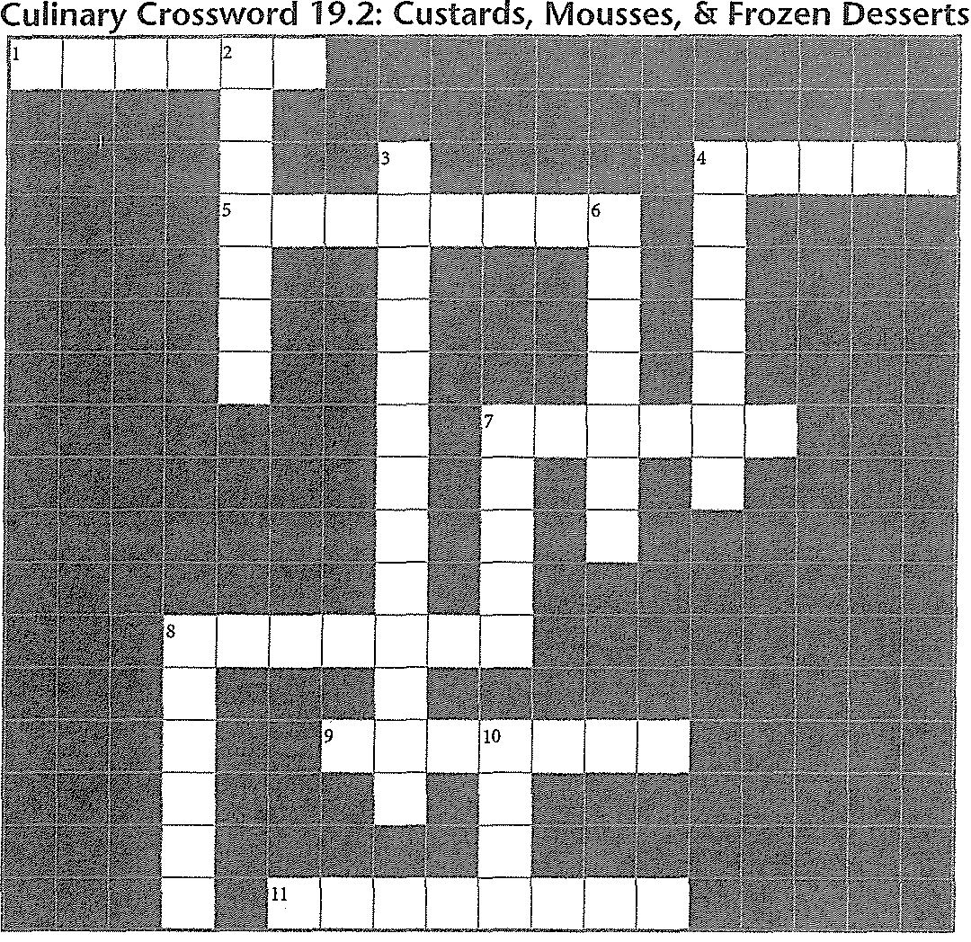

Use the clues below to solve the puzzle, wlzic/z contains vocabulary terms from Section 19.2.

Across
1. Dessert made by adding air to a flavored base
4. Sugar , concentrated solution of sugar and water
5. Process of adding air to food
7. Type of custard used to make pastry cream and cream pie fillings
8. Type of custard used to make an ice cream base
9. Frozen dessert that relies on egg foams and whipped cream for air
Down
2. Egg foam made by whipping egg yolks as they are heated with sugar
3. Airy dessert made without egg foam (2 words)
4. Frozen dessert that has meringue folded into it
6. Dessert made from a flavored water base that is stirred as it freezes
7. Type of custard made in the oven
8. Frozen, usually fruit-based dessert, made in an ice cream maker
10. Sweetened egg custard coated in caramel sauce

11. Mixture of stiffly beaten egg whites and sugar Answers are in the Crossword Solutions section.

Lab Resources & Study Guide ft;,. 253

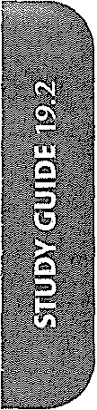

254 /IJ;. Introduction to Culinary Arts

Name -------------------- Date _

Cookies & Cakes
Chapter 19: Desserts

Use this Study Guide to take notes during class or as you read the section in the textbook.

Basic Ingredients in Cookies/Cakes
1.

2.

3.

4.

Additional Ingredients Found in Cookies/Cakes
1.

2.

3.

Main Types of Cookies and Examples
1.

2.

3.

'ci

ID

l!l

Tips for Working with Cookie Ingredients

· 1.
<i' 2.

3.

4.

5.

Tips for Preparing Cookie Pans
1.

2.

3.

(CONTINUES ON NEXT PAGE)

Lab Resources & Study Guide fit,. 255

Study Guide 19.3 (continued)

Mixing Methods for Cookies
1.

2.

Tips for Shaping Different Types of Cookies
1.

2.

3.

4.

5·-------------------------------------- ----------------

6.

z

8.

Cookie-Baking Factors
1.

2.

3.

4.

$.

Options for Finishing Cookies
1.

2·-------------------(CO-N-TIN=UES ON NEXT PA-GE-) -------------------­
256 1/;t. Introduction to Culinary Arts

Study Guide 19.3 (continued)
3.

4.

T,ips for Serving and Storing Cookies
2.

3.

4.

Tips for Preparing Cake Pans
1.

2.

3.

Mixing Methods for Cakes

1·---------- --------------------------------------------

2.

3·-------- ----------------------------------------------------

Cake-Baking Factors
1.

2.

3.

4.

5.

Options for Building, Icing, and Finishing Cakes
1.

2.

3.

g 4.

0 (CONTINUES ON NEXT PAGE)
w
c

ro
8:
@ Lab Resources & Study Guide 257

ne ---------------------------------------------- Dare
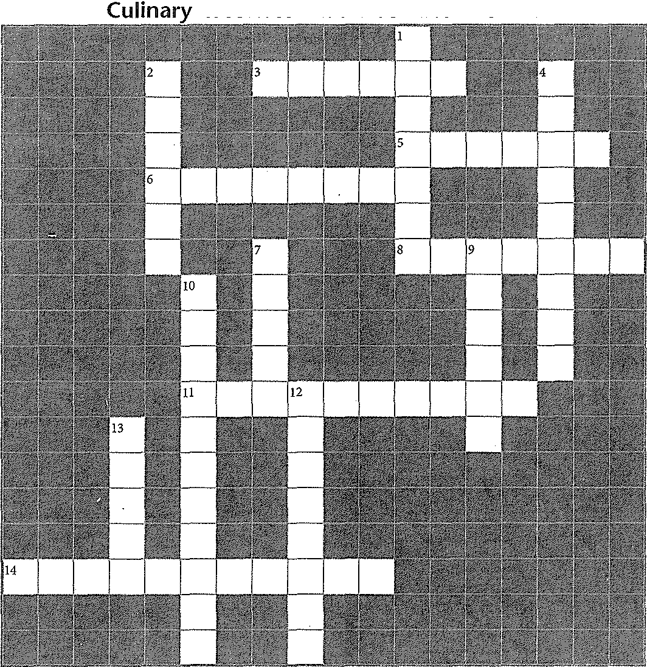Crossword 19.3: Cookies & Cakes

Use the clues below to solve the puzzle, which contains vocabulary terms from Section 19.3.

ISS
cookies, also called refrigerator cookies Type of cookie made with a stiff dough that is shaped by hand
Italian cookie that is twice-baked
Type of ingredient, such as chips, nuts, or icing, that is used in cookies and cakes You cut these into squares or other shapes after they are baked (2 words)
Joining two cookies together with a layer of filling or ice cream

/JJ;;. Introduction to Culinary Arts
Down
I. Cookie mixing method that includes whipped eggs.
2. -panning, stacking two cookie sheets
4. A tuile is this type of cookie
7. After greasing a cake pan, you coat it with this
9. cookies, also called cut-out cookies
10. Slowing down a mixer after the mixture reaches maximum volume
12. Cookie mixing method that produces smooth and uniform results
13. A spritz cookie is this type of cookie

Answers are in the Crossword Solutions section.

Name ---------------------Date

Pies, Tarts, & Pastries
Chapter 19: Desserts

Use this Study Guide to take notes during class or as you read the section in the textbook.

T,,ypes of Pastry Dough

2.

3·-------------------- ----------------------------------

Pie and Tart Fillings
1.

2.

3.

4.

Tips on Rolling Dough
1.

2.

3.

4.

5.

6.
z _

8.

(CONTINUES ON NEXT PAGE)

Lab Resources & Study Guide /It> 259

Jdy Guide 19.4 (continued)

ps on Blind Baking

ps on Assembly

rpes of Pie and·Tart Toppings

:houx Paste Ingredients

!.

L---------------------------
1. -------------:-=:=::--::cc:-:-::::: ::;-:----------­
(CONTINUES ON NEXT PAGE)

:»<11!:.1\ T'VIfrnrl11rt-inn fn rvlinarv Arts

Study Guide 19.4 (continued)

How to Use Choux Paste
1.

2.

3.

4.

5.

Tips on Plating Desserts
1.

2.

3.

4.

5.

6.
z

8·---------------------- ------ ----------------------------
(CONTINUES ON NEXT PAGE)

Lab Resources & Study Guide ._ 261

ne Date. _

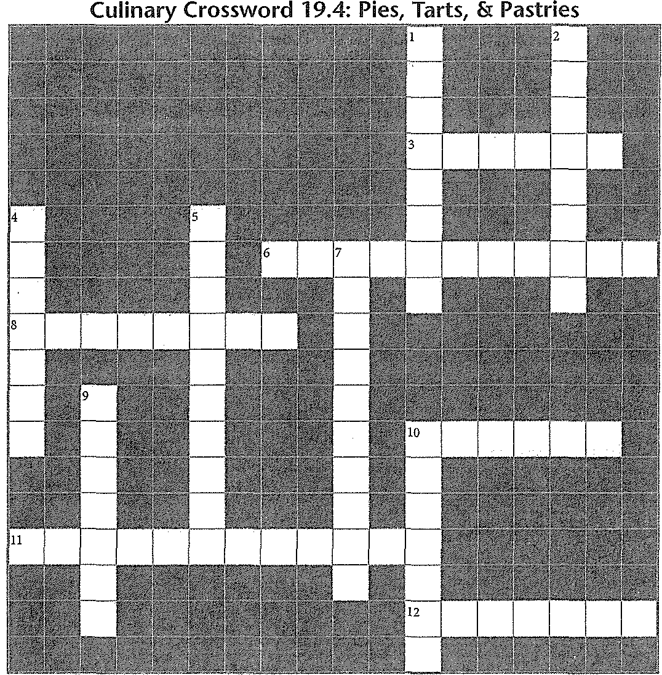
Use the clues below to solve the puzzle, which contains vocabulary terms from Section 19.4.

DSS
Long, straight pastry filled with cream and glazed on top
Method of mixing butter into dough with your hands (2 words)
Large piece of pastry dough placed over a filled pie shell before baking (2 words)
Type of fruit pie filling
Common covering for cream pies, it is usually piped (2 words)
Effect created,by weaving strips of dough across the .top of a pie filling

Z fi:>. Introduction to Culinary Arts
Down
1. Crumbly mixture sprinkled over a pie filling
2. Cream pie topping that browns in a hot oven
4. Pumpkin pie contains this type of pie filling
5. Versatile dough used by pastry chefs to create sweet and savory items (2 werds)
7. Another name for a pre-baked pie shell (2
words)
9. Squeezing pie dough between your fingers to create a decorative edge
10. Type of pastry dough used for pies; it is very rich in fat and sugar

Answers are in the Crossword Solutions section.

