INTRODUCTION TO CULINARY ARTS

STUDY **GUIDE**

**2012-2013**

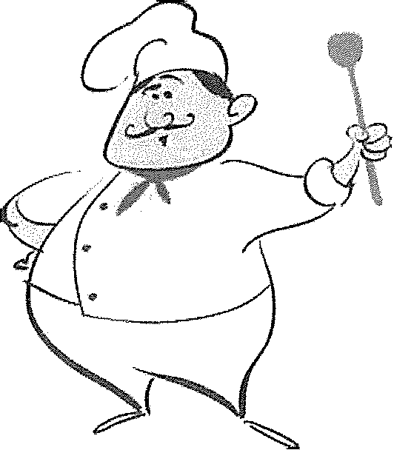

INSTRUCTOR NAME

STUDENT NAME



NAME DATE



Chapter 1

1.1 Sanitary Food Handling

1.2 The Flow of Food

1.3 HACCP System

Chapter 2

2.1Fire Safety

2.2Accidents & Injuries

*(;IJ* llii:'I 3

3.1 Work Flow in the Kitchen

3.2 Receiving & Storage

3.3 Preparation & Cooking Equipment

3.4 Holding & Service Equipment

*(;IJ* llii:'I 4

4.1 Using Knives

4.2 Using Smallware

Chapter **5**

5.1 Understanding Standardized Recipes

5.2 Converting Recipes

**Chapu:• 7**

7.1 Mise en Place

7.2 Learning to Work Together

7.3 Food Presentation

**NAME DATE**

.· ..



**DUE**

**DATE**

I .·. . . ·.. ·.··· . ·.. .··· .··. . .•. . ..·

1 ••..••• **• S RS.F? J0 2-2 3,.** '/.**·. i;··.·**

**Chapter 9**

9.1Eggs & Dairy

9.2 Breakfast Foods & Drinks

**Chapter 10**

10.1 Dressings & Dips

10.2 Salads

10.3 Cheese

10.4 Cold Food Presentation

**Chapter 17**

17.1 Introduction to Baking

17.2 Yeast Dough

17.3 Breads, Rolls, & Pastries

**Chapter 18**

18.1 Muffins & quick Breads

18.2 Biscuits & Scones

**Chapter 19**

19.1 Chocolate

19.2 Custards, Mousses, & Frozen Desserts

19.3 Cookies & Cakes

19.4 Pies, Tarts, & Pastries

Name ------------------------Date -------------



Sanitary Food Handling

Chapter 1:Sanitation

*Use this Study Guide to take uotes duriug class or as you read the section iu the textbook.*

**Potential Hazards**

**1.** Biological: -----------------------------

. 2.Physical:-----------------------------



**3.** Chemical: -------- --------------------

**FAT TOM**

**F**

l A ------------------------------------------------------

•***e* T**

B ---------------------------------------------------------------------

"· **T**

------------------------------------------------------



**0** ------------------------------------------------------

M-- ------------------------------

**Sources of Contamination**

**1.**

-----------------------------------------------------

2.---------------------------------

**(CONTINUES ON NEXT PAGE)**

*Lab Resources & Study Guide 59*

Study Guide 1.1 (CONTINUED)

Hand-Washing Procedure

1. -------------------------------------------------------

2. -------------------------------------------------------

3. ---- -------------- -------------------------------

4. ---------------------------------------------------------------

5. ------------------------------------ -----------------

6. -----------------------------------------------------------­

z ---------------------- -------------------------------



8. -------------------------------------------------------

9. ---------------------------------------------------------------

When to Wash Hands

1. ---------------------------------------------------------------

2. -------------------------------------------------------

3. ------------------------------------------------------------

4. -------------------------------------------------------

5. -------------------------------------------------------

6. --------------------------------------------------------------- z -------------------------------------------------------

8. ---------------------------------------------------------------



-------------------------------------------------------

10. ---------------------------------------------------------

Grooming and Hygiene Habits

1. ---------------------- -------------------------------

2. ---------------------------------------------------------------

3. -------------------------------------------------------

4. -------------------------------------------------------

5. ---------------------------------------------------------------

6. -------------------------------------------------------

7. ----------------------------------------------------

8. -------------------------------------------------------

(CONTINUES ON NEXT PAGE)

60 *!J;;. Introduction to Culinary Arts*

Study Guide **1.1** (CONTINUED)

Cleaning and Sanitizing

**1.**

2.

3.

4.

5.

;

. !

I

. I!



**Three-Compartment Sink**

**1. _**

2.

3.

**Waste Disposal and Recycling**

].

2.

3.

4.

5.

**Pest Control**

].

2.----------------------------------------------------------------

3.

4.-----------------------------------------------------

5.

(CONTINUES ON NEXT PAGE)

*Lab Resources & Study Guide* ,Jt. 61

Name Dme --

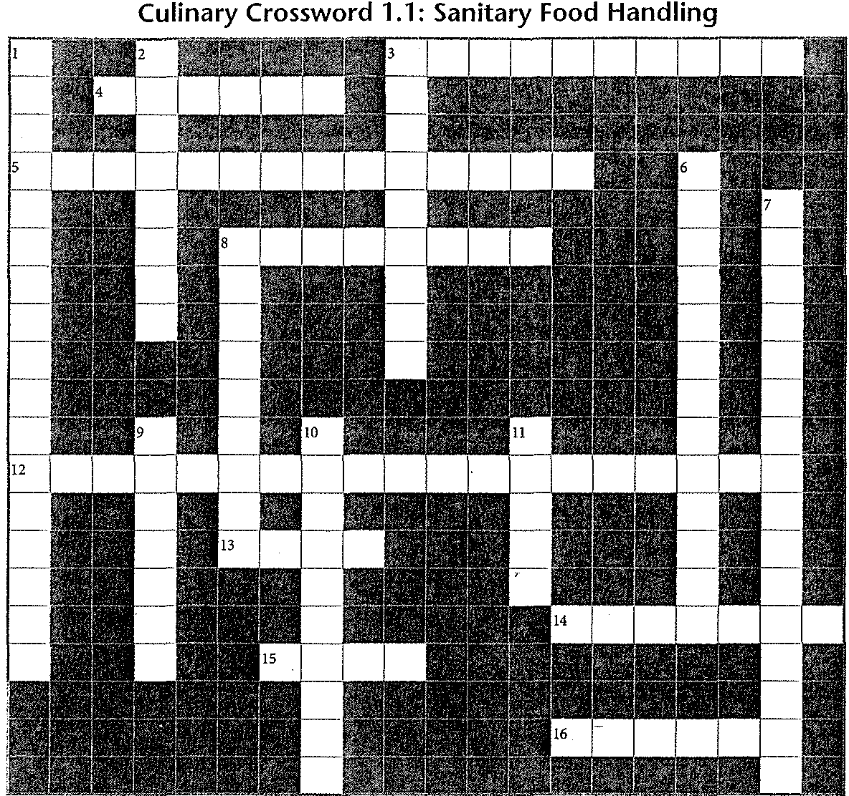

*Use the clues below to solve the puzzle, which contains many vocabulary terms from Section 1.1.*

**Across**

3. Using heat or chemicals to clean a surface

4. What "H" in "HACCP" stands for

5. Controlling rodents through cleanliness, maintenance, and pesticides (2 words)

8. Disease-producing organism

12. Result of improperly storing food, causing biological hazards in the food (2 words)

13. Three-compartment

14. Reuse glass or metal to cut down on waste

15. E. , bacteria found in raw beef

16. Mold is an example of this kind of biological hazard

***Answers are in the Crossword Solutions section.***

***62*** *(Jt. Introduction to Culinary Arts*

**Down**

1. Zone, 41°F to 135°F (2 words)



2. Single-celled organism that can live in food

3. They won't make you sick if eaten (2 words)

6. Measurement of moisture in food (2 words)

7. Sickness that results from eating something contaminated (2 words)

8. Multi-celled organisms that can live in food

9. Toxic metal found in fish

10. Biological hazard found in uncooked pork

11. Hepatitis A is an example of this type of biological hazard

Name ---------------------- Date ----------'----



The Flow of Food

Chapter 1: Sanitation

*Use this Study Guide to take notes during class or as you read the section in the textbook.*

Receiving Foods Safely

1. Perishable Goods:---------------------------

2. Dry Goods:----------------------------



Storing Foods Safely

1. Perishable Goods:---------------------------

2. Refrigerated Goods:---------------------------

3. Frozen Goods: _

4. Dry Goods:----------------------------

.,; S.FIFO: _

0

"

.E

0>

'C



Cooking Foods Safely

1. Preparing:------------------------------

2. Monitoring Temperature:--------------------------

**(CONTINUES ON NEXT PAGE)**

*Lab Resources & Study Guide fli,.* 63

Study Guide 1.2 (CONTINUED)

3.Coilling:

4.Thawing: _

Serving Foods Safely



1. Holding:------------------,--------------

2. Reheating:----------------------------------------------------------



(CONTINUES ON NEXT PAGE)

64 *fj.. Introduction to Culinary Arts*

ame Drue

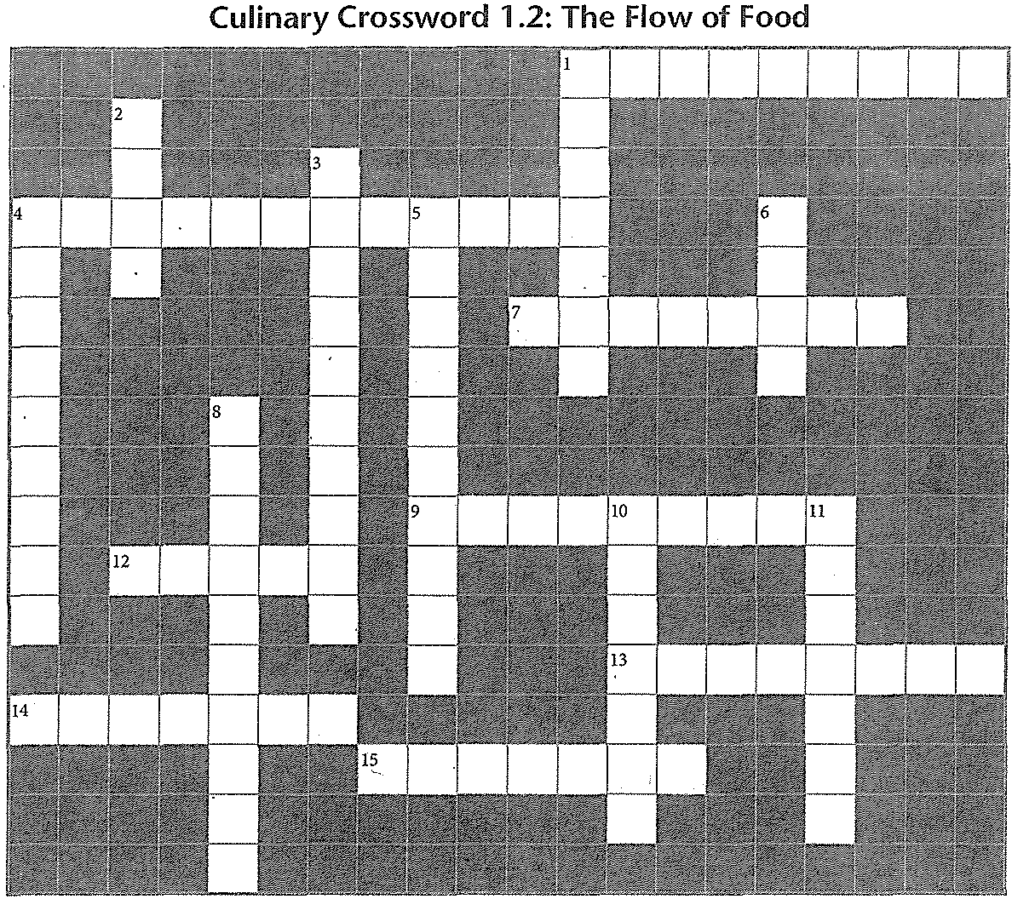

***Use the clues below to solve the puzzle, which contains many vocabulmy terms from Section 1.2.***

:ross

1. To cool liquids, first place in . steel containers

4. Place to store perishable foods

7. Method that cools food to below 41oF in the shortest time (2 words)

9. Safe amount of time required in 7 Across method (2 words)

2. Use a wand to cool liquids

3. Foods such as flour, tea, sugar, rice, and pasta are examples (2 words)

4. Place to store frozen goods

5. Place frozen food under water to thaw

***Answers are in the Crossword Solutions section.***

**Down**

1. Second step in flow of food

2. Abbreviation for "First in, first out"

3. goods must be kept cold or frozen

4. First step in flow of food

5. Time-temperature (2 words) is no longer safe to eat and must be discarded

6. You can use a microwave to frozen

foods safely

8. Use solution to keep tools and surfaces clean

10. Process of keeping prepared foods at the right temperature until it is served

11. Poultry should be 165°F for at least 15

before serving

*Lab Resources & Study Guide 65*



66 *[;., Introduction to Culinary Arts*



**Nmne** ----------------------Date

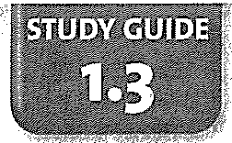

The HACCP System

.Chapter 1: Sanitation

*Use this Study Guide to take notes during class or as you read the section in the textbook.*

Food-Safety System

**1.** Food Code:----------------------------

2. Food Audit:-----------------------'------



**HACCP**

Stepl: _

-•ci Step 2:

•*e*

i'l

'"'

;;:

:"r:

.•

E

£ Step 3:

c

0

0

•

0.

0

"c'

.:E

:0

0

*J*

*E*

**·**"**g**

u,

w

c

0

0

*&'*

)

**(CONTINUES ON NEXT PAGE)**

*Lab Resources & Study Guide* 67

**Study Guide 1.3** (CONTINUED)

Step4:-------------------------------------------------------- StepS:-------------------------------------- ------------------- Step6:----------------------------------------------------------- Step"7:--------------------------------------------------------



(CONTINUES ON NEXT PAGE)

68 */iJ. Introduction to Culinary Arts*



Name

Date _

Culinary Crossword 1.3: The HACCP System

' .

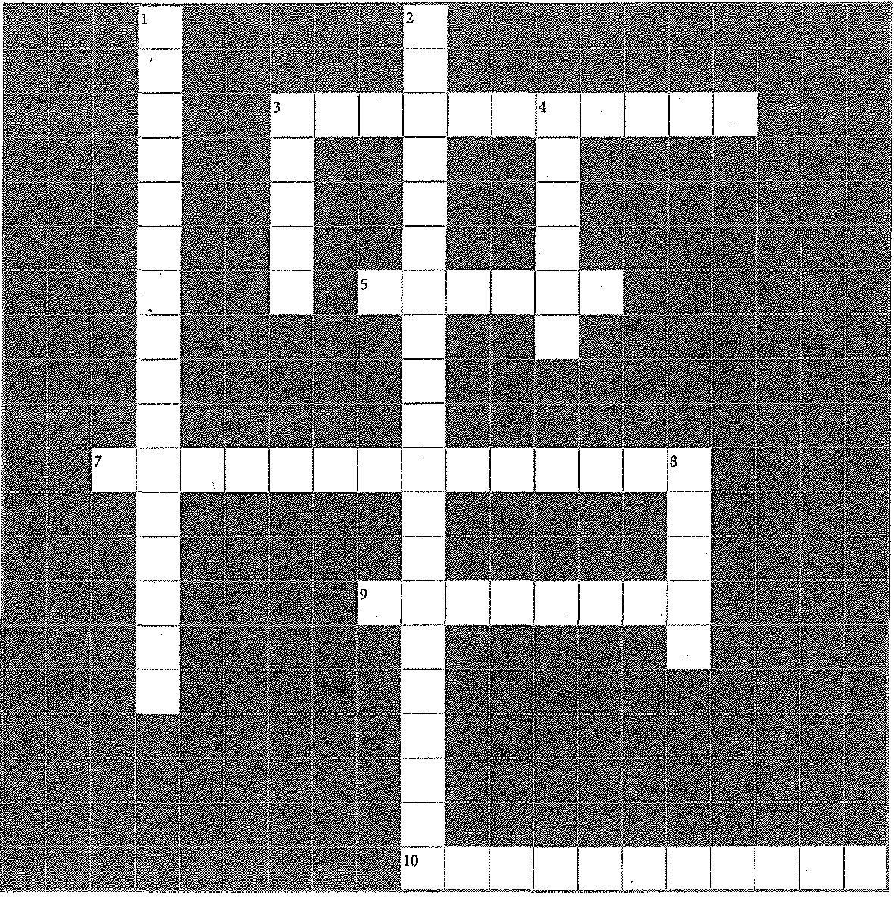

***Use tlze clues below to solve the puzzle, which contains ntany vocabulary terms from Section 1.3.***

Across

3. What ''A" in "USDA" stands for

5. Food- system (precautionary steps that take into account how food can be exposed to hazards)

7. First step ofHACCP (2 words)

9. FDA , set of recommendations for safe food handling that may be adopted by local governments (2 words)

10. HACCP step 4: record measurements of time

and in a log book

***Answers arc in the Crossword Solutions sectio11.***

**Down**

I. What to identify in step 5 of HACCP (2 words)

2. What "CCP" in "HACCP" stands for (3 words)

3. Food-safety (inspection by the local health department)

4. HACCP step 3: establish critical that

indicate when food is at risk

8. Number of steps in HACCP system

*Lab Resources & Study Guide* 69

Name

De

**Culinary Crossword 1.3: The HACCP System**



« **Across**

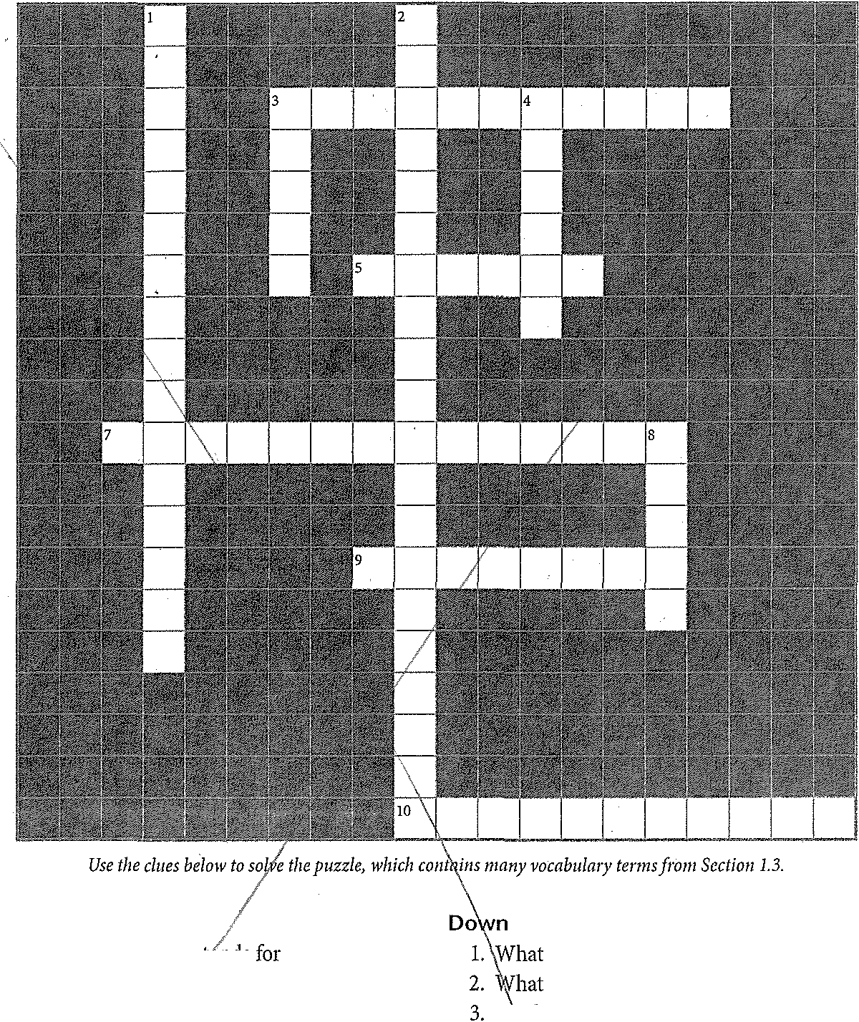

3. What *"A:'* in "USDA:' >)tt,uuo



5. Food- sys>terp1(pl·ecauti<mar steps that take into accom1t;howfood can be exposed to hazards)

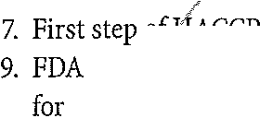

V>, U>.lovr (2 words)

*--+- ,set* of recommendations

'a'' wc>u handling that may be adopted by loc<I}tg<wer·nments (2 words)

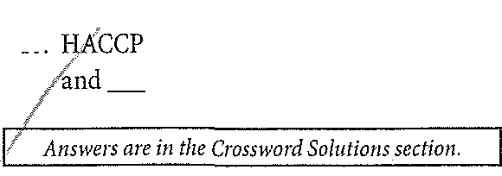

to identify in step 5 of HACCP (2 words) "CCP" in "HACCP" stands for (3 words)

!'<:lc>d-s:atetv (inspection by the local

uc''\'u department)

4. u"'" -r step 3: establish critical that mdica :ewhen food is at risk

8. Nu:mb·B!· of steps in HACCP system



10.

step 4: record measurements of time

in a log book

*Lab Resources & Study Guide* 69

Name ----------------------------------------------- Date

**STUDY GUIDE**

**l.ll**

Fire Safety

Chapter 2: Kitchen Safety



*Use this Study Guide to take notes during class or as yotread the section itz the textbook.*

Causes of Fire

1.

2.



3. ---------------------------------------------

4.

5.

Methods of Fire Control

1. _

2.

ai

&

s

"."•'' 3.

:t

"

8

**·g**

•

<1:

0 4.

.•f

•

"0'

:E

•:c•

, 5.

*0.*

*J E* c

0

,3

w **(CONTINUES ON NEXT PAGE)**

0

•

@ *Lab Resources & Study Guide*71

Study Guide 2.1 (coNTINUED)



**PASS System**



p

------------------------------------------------------

A

s ------------------------------------------------------

5

**F**,**ire Extinguishers**

2.

3.

**C**,**lasses of Fire**

2.

3.

4.

5.

**F**,**ire Emergency Plans**

2.

3.

(CONTINUES ON NEXT PAGE)

**72 *!J;.*** *Introduction to Culinary Arts*

Study Guide 2.1 (coNTINUED)

What to Do in Case of Fire:

1.

2.

3.

4.

5.

6.

(CONTINUES ON NEXT PAGE)



*Lab Resources & Study Guide* _. 73

Name _ Date---------

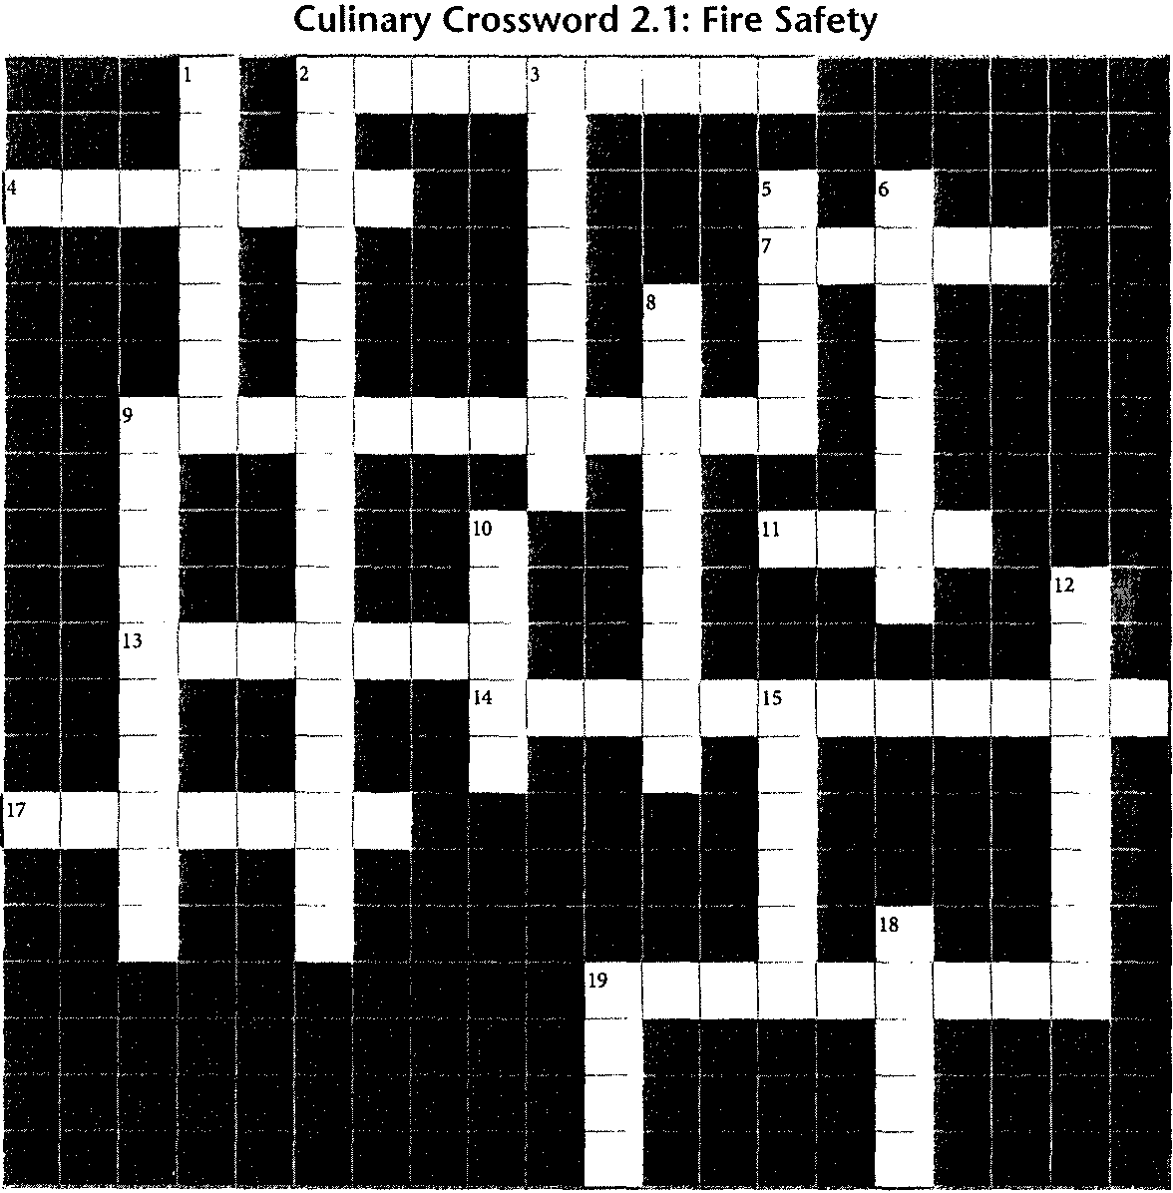

*Use the clues below to solve the puzzle, which contains many vocabulary terms from Section 2.1.*

**Across**

2. Fire plan, established plan of action in case of fire

4. A common fuel source is gas

7. The act of deliberately setting a fire

9. Fire warning device activated by sudden rise in temperature (2 words)

11. the pin, step 1 in PASS system

13. Unsafe areas can become fire hazards

14. Fire , handheld device for putting out fire

17. Overloaded can cause electrical fires

19. Practicing procedures in case of fire (2 words)

***Answers are in the Crossword Solutions section.***

**74** .. *Introduction to Culinary Arts*

**Down**

1. the trigger, step 3 in PASS system

2. Ways to escape in case of fire (2 words)

3. Type of plug with three prongs

5. -based extinguisher, for Class A fires

6. points, places to meet away from building in case of fire

8. Type of fire system triggered by heat of fire

9. Fire detection device installed over grill or range (2 words)

10. from side to side, step 4 in PASS system

12. Dry- extinguisher

15. A layer of this on equipment can cause fire

18. Class K fire can be caused by a deep-fat

19. extinguishers cool down and blanket

Name --------------------Date ---------



Accidents & Injuries

Chapter Kitchen Safety



*Use this Study Guide to take notes during class or as you read the section in the textbook.*

Types of Burns

1.

2·-------------------------------------- ----------------

3. ------------------------------------------

Types of Cuts

1·-------------------------------------------- ----------

2.

3·------------------- ----------------------------------------

4.

Strains, Sprains, and Falls

Causes:------------- ------------------

Protective Articles of Clothing

1·-------------------------------------- ----------------

2.

3·-------------------- ----------------------------------------

4.



5·------------------------------ ---------------- ----

6.

z---------------------------------------- --------------

8.

VVhmNotToVVear:

Handling Knives Safely

1.

2.

3.

4.

5·-------------------- ---------------------­

(CONTINUES ON NEXT PAGE)

*Lab Resources & Study Guide /111:.* 75

Study Guide 2.2 (CONTINUED)

6.

z

8·-------------------------------------------------------- ----

Handling Other Cutting Tools Safety

**1.**

2.

3.

4.

5.



Preventing **Burns**

1.HotPans:

----------------------------------------

2.Steam:

3. Oven Heat:---------------------------------------------

4. Oil/Grease:-------------------------'---------------- -----,

Safety Tips

**1.** Avoiding Slips and Falls:------------------ -----------------------



*2:* Cleaning up Spills: -----------------------------------;----------------

3.Lifting and Moving Heavy Objects:-------------------- -----------

4.Using a Ladder:---------------------------------------------

5.Drwing:

Contents of a First Aid Kit

-----------------

76 *Introduction to Culinary Arts*

**(CONTINUES ON NEXT PAGE)**

Study Guide 2.2 (CONTINUED)

Emergency Procedures

1.ForBurns:

2.ForCuts: _

3. For Sprains, Strains, and Broken Bones:----------------------------------------

4. For Choking:------------------------------ ----------------------­ Heimlich Step 1: -----------------------------------------------------­ Heimlich Step 2: --------------------------------------------------------



5.CPR: _

6.AED:------------------------ ---------------------------

**Preparing for EmergenCies** . ·

**1.**

' ,< >

**-------------------------------------- ------------**

2.

---------- -- --------------------

3·------------------------------------ -- --------------

4. ';;'

--------------

5.



Safety as an **Ongoing** Process

1.0SHA: ---------------- -----------------

2. Hazard Communication Standard:-----------------------------------------

3.MSDS: --------------------------------------

4. Hazard Communication Program:-'------------------ ---------------------

5. Accident/Illness Reports and Records:---------------------------------------

6. Worker's Compensation: --------------------------------------------------

7. General Safety Audit: -------,--------------------------------------------

**(CONTINUES ON NEXT PAGE)**

*Lab Resources & Study Guide Jl;t.* 77

Name Dme

**Culinary Crossword 2.2: Accidents & Injuries·**

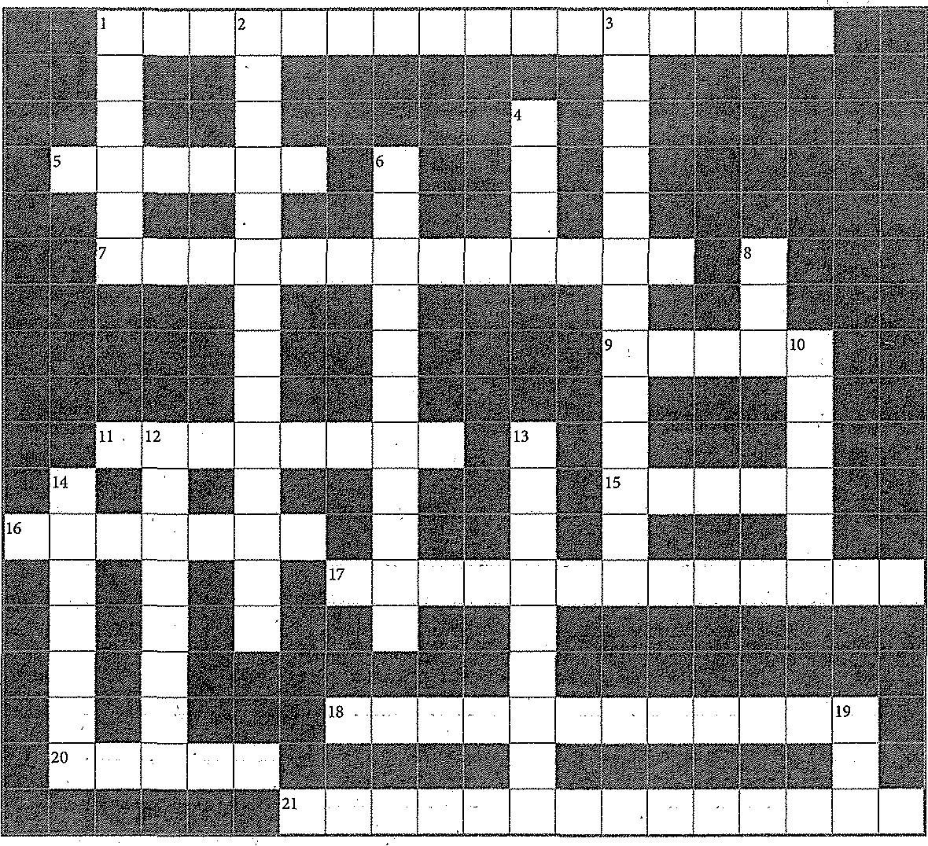

**Across**

. *Use the clues below to solve the puzzle, which contains many vocabulary terms from Section 2.2.*

**Down**



1. First aid technique performed on someone choking (2 words)

5. Storage area item you should step on carefully

7. Type of device an AED is

9.. Handle hot pots with oven to protect hands from burns

11. Slipping can cause a ankle

15. Part of chef uniform worn on head

16. Carry a knife with the blade down

17. audit(Zwords)

18. Causing cancer, such as toxic chemical exposure

20. When you open a pot lid, this can cause burns

21. Form filed when an injury occurs (2 words)

***Answers are in the Crossword Solutions section.***

78 *flp,. Introduction to Culinary Arts*

1. Communication Standard

2. · Data Sheet (MSDS) (2 words)

3. Protection Agency (EPA)

4. Federal agency in charge of keeping workplace safe

6. Most.serious type ofburn (2 words)

8. Avulsion is a type of

10. Part of chef uniform that protects arm from burns

12. Cut that makes a hole in skin

13. Having ability to irritate or eat away skin

14. compensation program

19. First aid technique to restore breathing and heartbeat

Name ---------------------------------------------- Dffie

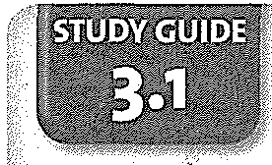

Chapter 3: Food Service Equipment

Work Flow in the Kitchen

*Use this Study Guide to take notes during class or as you read the section in the textbook.*



Work Areas

1. Workstations: -------- ---------------- ------ -----------------

2. Work Sections: --------------------------------------------



Work Lines

1---------------------------------------------------------------

,2·---------------------------------------- --------------------

-•ci

•"

3.

i'l

-

r" 4.

•

.2

E

n.

c

0*e*

n•.

"• 5.

.s

•:0•

"

.0s

**(CONTINUES ON NEXT PAGE)**

2

0

-

0

"

"0

w

c

0*e*

•

*8'*

@

*Lab Resources & Study Guide /JJi,. 79*

Study Guide 3.1 (CONTINUED)

Work Flow

1. Plannings: ---------------------------------------------------------

2. Timing: ------------------------------------------ ---------------

3. Communication: -----------------------------------------------------



**(CONTINUES ON NEXT PAGE)**



•

80 *Introduction to Culinary Arts* ·

Name ----------------------------------------- Drue _

Culinary Crossword 3.1: Work Flow in the Kitchen

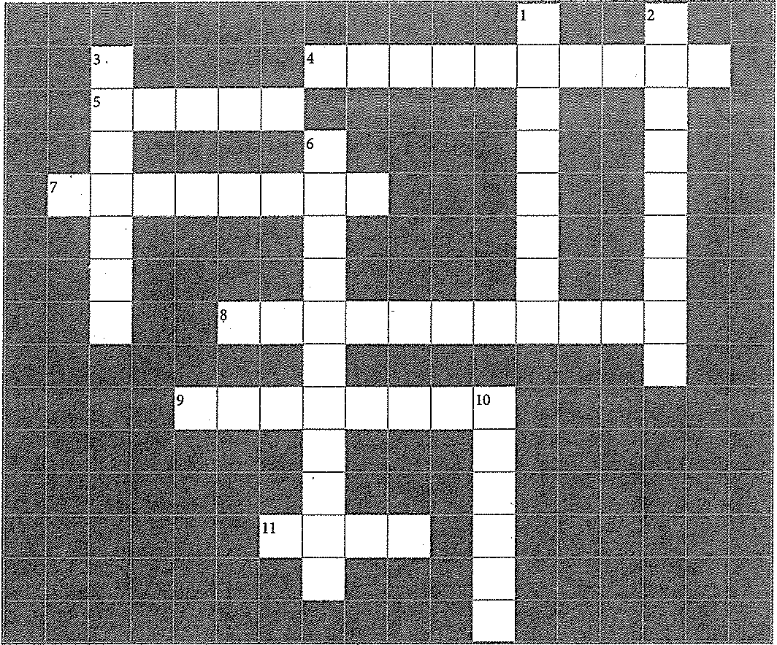

*Use the clues below to solve the puzzle, which contains many vocabulmy terms from Section 3.1.*

•ro



:E

·"

:0

0

"-

"

*E*

c

.2

1§

0

'0

w

c

Across

4. Where all fried food in a kitchen is prep red

(2 words)

5. Kitchen arrangements include parking spaces for these

7. Planned movement of food and kitchen staff as food is prepared (2 words)

8. French term meaning "to put in place" (3 words)

9. -line arrangement, the most efficient

kitchen arrangement

11. surface, a general area for food preparation

***Answers are in the Crossword Solutionsection.***

**Down**

1. What a face-to-face work area arrangement is called

2. Geometric arrangements of equipment

(2 words)

3. Saying "Yes chef" and repeating the chefs order

6. Area containing tools and equipment needed to accomplish a specific culinary task

10. Good is when there is no delay in

serving courses

ro

*8:*

© *Lab Resources & Study Guide* 81



*8i It;. Introduction to Culinary Arts*



Name ---------------------Date



Chapter 3: Food Service Equipment

Receiving & Storage Equipment

*Use this Study Guide to take notes during class or as you read the section in the textbook.*

Receiving Equipment

1.

2.

3.

4.

5.

Types of Refrigeration Equipment

1.

2.

3·------------------------------ ---------- ------------

4.

5·-------------------------------------------------- --

Cleaning Refrigerators and Freezers

1.

2.



3.

4.

5.

6.

z

8.

(CONTINUES ON NEXT PAGE)

.E"

c'

0

-,

"0

"c'

0

,ll

@ *Lab Resources & Study Guide /11:>.* 83

Study Guide 3.2 (CONTINUED)

StoragAreas/Type of Goods

1·---------------------- -- ----------------------------

2·---------------------------------------------------- --

Storage Equipment

1. Shelves:------------------------------

2. Containers:-------------------------- ---



Cleaning Shelves and Storage Containers

1. ------------------------------ -------- ----------

2. ------------

3.



4·-------------------------------------- ----------------------

5.

6.

(CONTINUES ON NEXT PAGE)

84 *Introduction to Culinary Arts*

Ne Dme

**Culinary Crossword 3.2: Receiving & Storage Equipment**

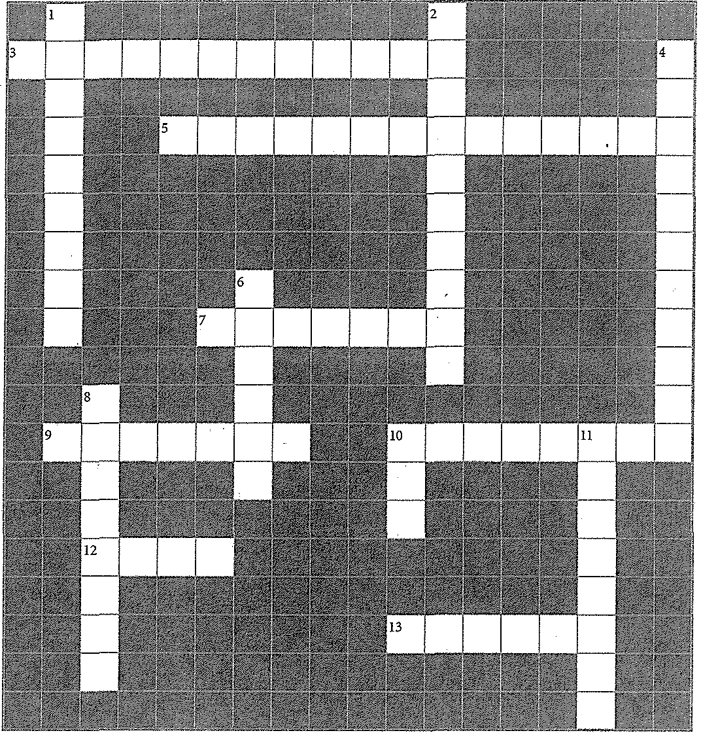

**Across**



***Use the clues below to solve the puzzle, which contains many vocabulary terms from Sectio11 3.2.***

**Down**

3. reach-in, also called a low boy, located at a workstation



5. Common material for kitchen shelves

(2 words)

7. scale, weighs items by lifting them on a hook

9. Common material for storage containers

10. To clean refrigerators, yon should the interior with a solution

12. Label stored foods so you can use the

system and know which food is oldest

13. Refrigerated , small but efficient refrigeration unit

***Answers are in the Crossword Solutions section.***

1. Type of container keeps food hot or cold

2. area, where flour and canned goods are kept (2 words)

4. area, where refrigerated goods

are kept (2 words)

6. Largest type of refrigeration unit (hyphenated woi·d)

8. scale, used to weigh bulky packages

10. Number of inches shelving units usually stand from the floor

11. Type of thermometer that scans food without touching it

*Lab Resources & Study Guide /IJI.* 85



*J*

86 */JJ>. Introduction to Culinary Arts*

-•ci

•0*e*0

l'l

-

<(

:"c

0

a*e*.

c

0

E

m

•

a.

00

m

"c'

·:"c"'

0

0.

*J*

*E*

c

·a

m

0

0 "0'

w

c

0

E

m

•

a.

@)

Name ------------------- Date _

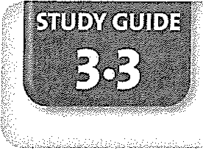

Chapter 3: Food Service Equipment

Preparation & Cooking Equipment

*Use this Study Guide to take notes during class or as you read the section in the textbook.*

Safety Checklist for Food-Preparation Equipment

---------------- -----------------------------------­

------------------------------------------------ ---­

-------------------------------------------------------­



-----------------------------------------------------­

-----------------------------------------------------­

------------------------------------------ -------------

opping, Slicing, and Grinding Equipment

C,.h

__

2.

3.

4.

5.



zes of Mixers

S,.i

__

2.

pes of Mixers

T,.y

_

2·-------------------- ----------------------------------

(CONTINUES ON NEXT PAGE)

*Lab Resources & Study Guide 1;;.* 87

Study Guide 3.3 (CONTINUED)

Types of Blenders

1. ---------------------------- -----------------------

2. -------------------------------------------------------

Cleaning Food-Preparation Equipment

1. -------------------------------------------------------

2. ---------------- -------------------------------------

3. -------------------------------------------------------



4. ------------------------------ -----------------------

5. ---------------------------------- ------------------------

6. ------------------------------------------------------­

z ------------------------------------------------------------

8. -- ---------------------------------------------------

9. ---------------------------------- -------------------

10. -------------------------------------------------------

Cooking Equipment

1. ------------------------------------------------------------

2. -------------------------------------------------------

3. ----------------------------------------------------------

4. -------------------------------------------- ---------



5. --------------------- ---------------------------------

6. -----------------------------------------------------------­

z -------------------------------------------------------

8. ------------------------------------------------------------

9. ---------------- -------------------------------- --------

10. ---------------- ---------------------------------------

11. ------------------------------------------------------------

12. ---------------------------------------------- ----------

13. ------------------ -------------------------------------

14. ------------------------------------------------------------

(CONTINUES ON NEXT PAGE)

88 */1;.. Introduction to Culinary Arts*

Study Guide 3.3 (CONTINUED)

15. -------------------------------------------------------

16. ------------------------------------------------------------

17.

18.

Cleaning Cooking Equipment

GenerruRllies: -----------------------------------------------------------

1. ,.---------------------- -----------------------------



2. ------------------------ ----------------------------------

3. ---------------------- -------------------------------

4. -------------- -- ---------------------------------

5. ---------------------- ------------------------------------

6. ------------ ------------------ ---------------------

7.

8.

9.

10.

**(CONTINUES ON NEXT PAGE)**

*Lab Resources & Study Guide /i»* 89



Name Date

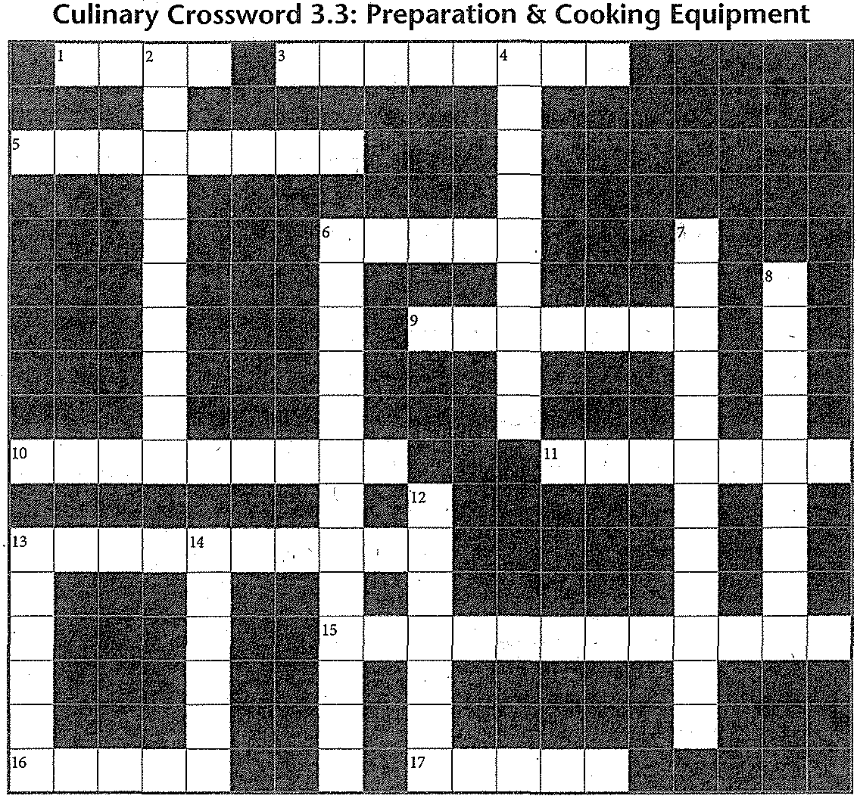

**Across**

*Use the clues below to solve the puzzle, which contains many vocabulary terms from Section3.3.*

**Down**

1. Type of ovens that are stacked, one above the other

3. Vertical machine (VCM)

5..Chopping ingredients to a uniform consistency

6. Deep-fat cooks food in hot oil ·

9. Solid cooking surface often used to make hot sandwiches

10. Type of mixer with a stationary bowl

11. Type of range made of a solid metal plate over a heat source

13. Machine with a carrier that moves back and forth against a circular blade (2 words)

15. Type of kettle, also called a tilting skillet

(2 words)

16. It cooks food on a rack over a heat source, such as ,gas or burning charcoal

17. General name for a stovetop

90 */iJ. Introduction to Culinary Arts*

2. Type. of steamer in which pressure doesn't build up

4. Type of blender that is hand-held



6. Machine that slices, grinds, mixes, blends, and crushes food (2 words)

7. Type of mixer that sits on the floor

8. Oven that uses a type of radiation -

12. It cooks food quickly with a heat source directly above the food

13. Combining ingredients so they are evenly

spread throughout

14. Type of mixer with a turning bowl

***Answers are in the Crossword Solutions section.***

Name ----------------------Date



Chapter 3: Food Service Equipment

Holding & Service Equipment

*Use this Study Guide to take notes during class or as you read the section in the textbook.*



Holding Equipment

1.



":r:

"c'

2. ----------------------------------------------------

3.



4·---------------------------- ------------------------

5·------------ ------------------------------------------

6·---------------------------------------- --------------

Safeguards for Holding Foods

1. _

**2.**

c ------------------------------------

'.

0

ro

a.

•ro

..

0>

c

:0

:0

0

0

*E*"

c

0

"ro'

0

0

'0

w

c

0

ro

.l:

©

**(CONTINUES ON NEXT PAGE)**

*Lab Resources & Study Guide /1>* 91

Study Guide 3.4 (CONTINUED)

Hotel Pans

Space for 1 full size pan can be occupied by these combinations:

1·-------------------------------------------------- ----

2.

3.

4·-------------------------- ----------------------------------

s.

6.

z------------------ ------------------------------------------



8.

Service Equipment

1.

2.

3.

4·---------------------------------------------------- -----

(CONTINUES ON NEXT PAGE)



92 /Jir;. *Introduction to Culinary Arts*

Nrune Dffie ------------

Culinary Crossword 3.4: Holding & Service Equipment

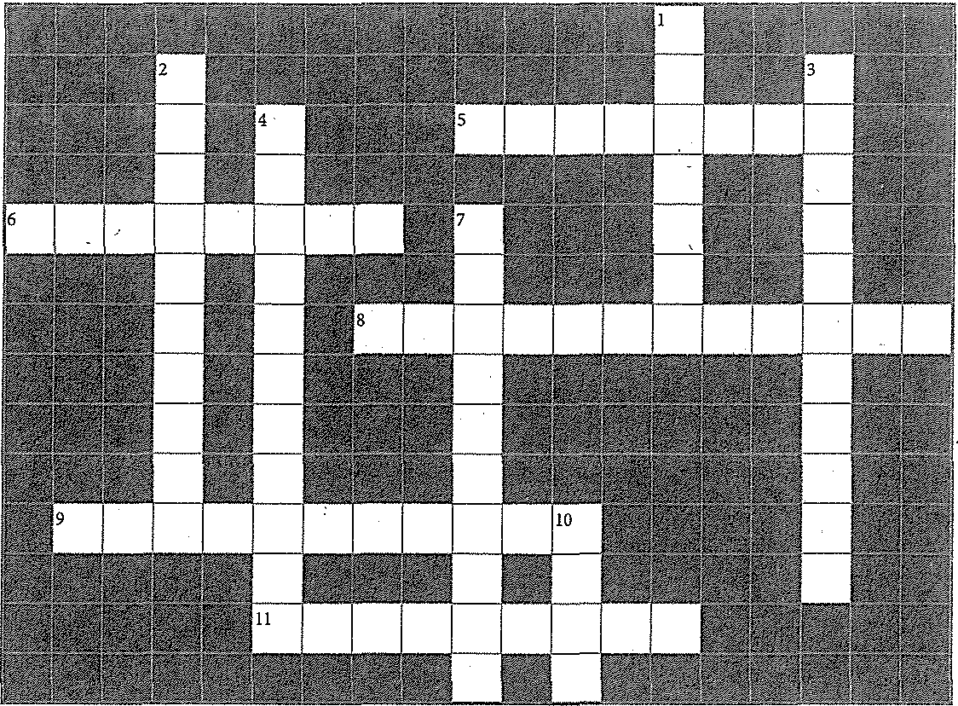

*Use the clues below to solve the puzzle, which contains many vocabulary terms from Section 3A.*

Across

5. Electrical appliance that keeps coffee and water ready for service (2 words)

6. It has a special bulb and is placed over food to keep it warm (2 words)



8. See-through barriers that protect food at a buffet or cafeteria (2 words)

9. It is used in the dining area to carry food or provide a work surface for plating or assembling dishes by a table (2 words)

11. Various size stainless steel or plastic containers used for holding and storing food (2 words)

r"o

".:E.

**g> *Answers are in the Crossword Solutions section.***

,

0.

."E

c

0

"

ro

0

"

'0

w

c

0

,11

Down

1. A cabinet is enclosed, insulated, and on wheels

2. It keeps food warm that must be carried a distance to a customer, and is removed when the food is served (2 words)

3. Holding quipment is used to keep food at a safe

4. It consists of a stand, a water pan, an insert pan, and a lid (2 words)

7. It holds containers of cooked food kept warm by hot water (2 words)

10. It is used to transport dishes from the kitchen to the dining area

@ *Lab Resources & Study Guide* 93



94 *I/JI,. Introduction to Culinary Arts*



Name -----------------------Date ----------



Using :Knives

Chapter 4: Knives and Smallware

*Use this Study Guide to take notes during class or as you read the section in the textbook.*

Parts of a Blade

1.

2.

3. -------------------------------



4.

----

5. --------

6.

Tang: _c_ _

Handle:--------------------------------

**Type of Knives and Usage**

**1. _**

2.

3.

-•ci 4.

•w

*11*

m

'<0

5.

"

I"

•

0

"c'

"- c

6.

0

ro

r"o m

:c

••

:0

0

0

"

"'

c

0

"ro'

0

0

"

w

c

0

ro

•

"-

Ql

7.

8.

**(CONTINUES ON NEXT PAGE)**

*Lab Resources & Study Guide fj..* 95

Study Guide 4.1 (CONTINUED)

Methods for Holding a Knife

1. -------------------------------------------------------

2. -------------------------------------------------------

3. -------------------------------------------------------

Using the Guiding Hand



1. ------------------------------------------------ -----

2. -------------------------------------------------------

3. -------------------------------------------------------

4. -------------------------------------------------------

Knife Safety Points

1. -------------------------------------------------------



2. -------------------------------------------------------

3. -------------------------------------- --------------------



4. -------------------------------------------------------

*5.* -----------------------------------------------------

6. -----------------------------------------------------------­



z ---------------------------------------------------------

8. ------------------------------------------------------------

\ 9. -------------------------------------------------------

10. ---------------------------------------------------------

Basic Cutting Techniques

1. -------------------------------------------------------

2. ------------------------------------------------------------

3. ------------------------------ -----------------------

(CONTINUES ON NEXT PAGE)

96 */IIJ;,. Introduction to Culinary Arts*

Study Guide 4.1 (cONTINUED)

Types of Precision Cuts

1. -------------------------------------------------------

2. ------------------------------------------------------------

3. -------------------------------------------------------

4. -------------------------------------------------------

5. ------------------------------------------------------------

6.------------------------------------------------------­

z-------------------------------------------------------



8. ------------------------------------------------------­

-------------------------------------------------------

**10.** ------------------------------------------------------------

**11.** -------------------------------------------------------

12.

13. ---------------------------------------------------------

14. ---- ---------------------------------------------------

**Maintaining 1\nives**

**1.** Sharpening: _

2. Cleaning and Sanitizing: ------------------------------------------------



3. Storing Knives:-----------------------------------------------------

4. Maintaining the CuttingSurface:-----------------------------------------

(CONTINUES ON NEXT PAGE)

*Lab Resources & Study Guide /JI;.* 97

Name, pMe,



**Across**

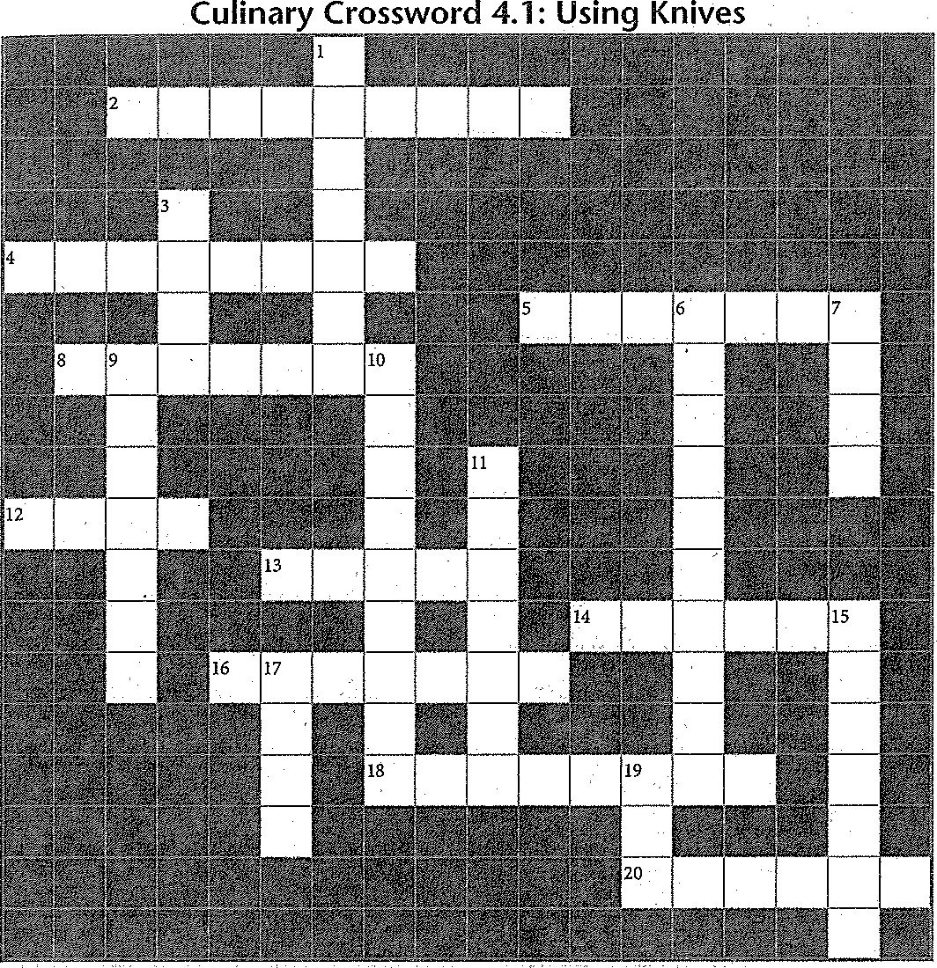

*Use the clues below to solve the puzzle, which contains many vocabulmy terms from Section 4.1.*

**Down**



2. Slicing tool that can make waffle cnts

4. Long, rectangular Ys-inch cut (example: French fries)

5. Cutting food more finely than chopping

8. Type of knife with a rectangular handle; it is the Chinese equivalent of a chef's knife

12. Widest and thickest part of a knife blade

13. A rod used to maintain a knife's edge

14. Process of straightening a knife's edge

16. Type of knife that is a similar and lighter version of a chef's knife

18. Type of knife edge that has a row of teeth

20. Type of knife used for peeling and trimming fruits and vegetables

***A11swers are in the Crossword Solutions section.***

98 *1/J;.. Introduction to' Culinary Arts*

1. Small knife with a cnrved blade

3. Cube-shaped cut

6. Fine cut made by stacking, rolling, and slicing

7. The coarseness or fineness of a sharpening stone

9. Diamond-shaped cut

10. French term for round-shaped cuts

11. Part of a knife where the blade and handle come together

15. When peeling food, the hand holds and

turns the food gainst the blade

17. The continuation of the blade into the knife's handle

19. Part of the knife used for paring, trimming,

peeling

Name ---------------------Date _



**STUDY: GUIDE**

'?21::0

Using Smallware

Chapter 4: Knives and Smallware

*Use this Study Guide to take notes during class or as you read the section in the textbook.*

|  |  |
| --- | --- |
|  |  |
|  |  |
|  | . **,1·•** |

Categories of Hand Tools

1.

2.

3.

4.

5.

Cutting and Slicing Tools

1. -------------------------6. --------------------------

2. ?.

3. 8.

4. 9. ------------------------

5. 10. _

Shredding and Grating Tools

1.

2. ------------------

3.

4. ------------------------

Mixing and Cooking Tools

1.------------------- 6.--------------------

2. z

3. 8. _

4. 9.---------------------

5. 10. --------------------------

**(CONTINUES ON NEXT PAGE}**

*Lab Resources & Study Guide* j;. *99*



Study Guide 4.2 (CONTINUED)

Straining, Draining, and Processing Tools



1.

2.

3.

4.

5.

6.

Measuring Tools

1. Weight:

2.Volume:

3-. Temperature:------------------------------

Cookware Materials

1.

2.

3.

4. _

5.

6.

Stovetop Cookware

1.

'J

1

·

6. 1

'1

2. z-------- ------------------- '

3. 8. --------------------------- '"

"

'

4. 9. ·'

5.

'

£

(CONTINUES ON NEXT PAGE) ·'

*i*

"

'

'1

100 /it. *Introduction to Culinary Arts* @



,;

•

•f

.E

·

;;;

"•

E

0.

0

0

•

•

0>

0

•":0•'

0.

*R: J*

.E

'

c

Study Guide 4.2 (CONTINUED)

O,ven Cookware



32.----- ---------------------------------------------------

4.

5.

6.

z

**S**,**teps for Using a Three-Compartment Sink**

23.---------------------------------------------------------------

4.

5.

6.

**T**,**ypes of Dishwashers**

23.---------------------------------------------------------------

**(CONTINUES ON NEXT PAGE)**

;,,,

.•2

t ,u

'0

k w

'i:'

f

0

0

8•:

@

*Lab Resources & Study Guide /hi.* 101



**Across**

*Use the clues below to solve the puzzle, which contains vocabulary terms from Section 4.2.*

**Down**

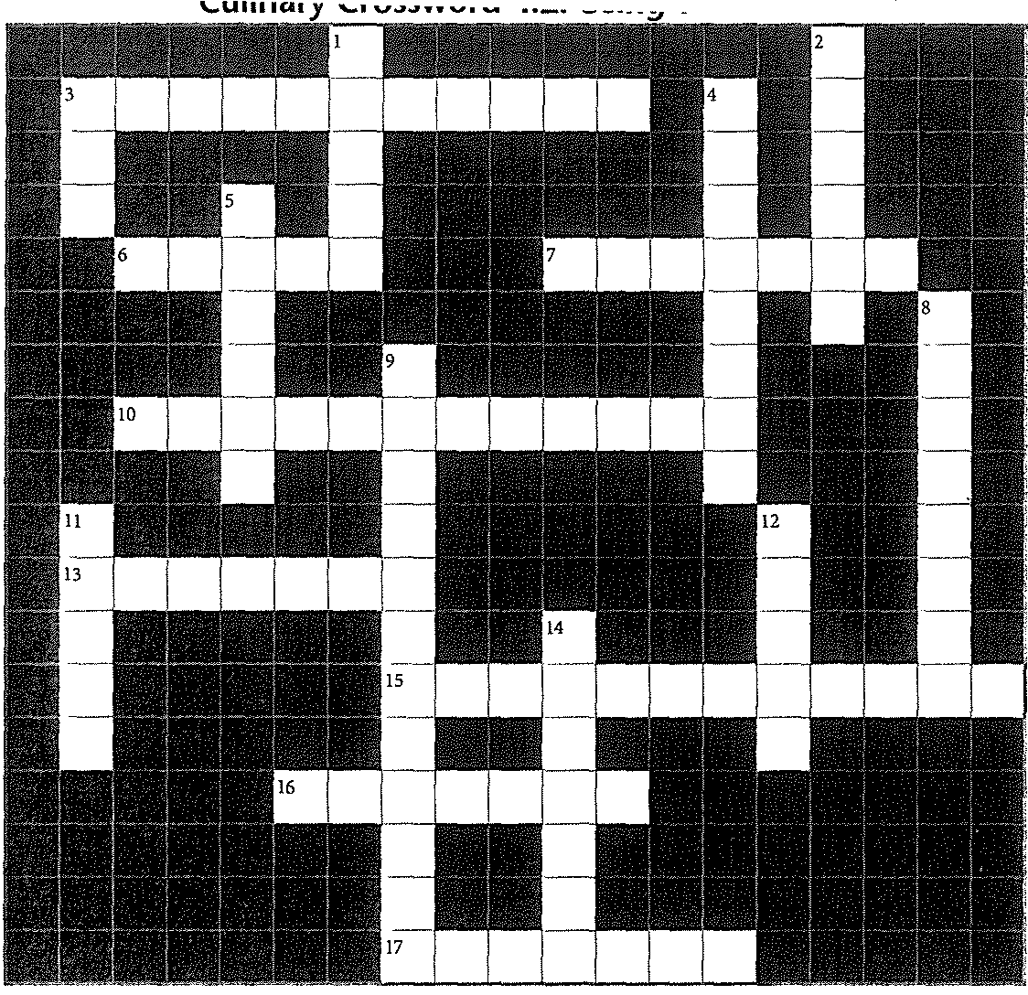

3. station, area where dishes are cleaned and held

6. Thickness of cookware

7. Set of stacked pots or bamboo baskets with a tight-fitting lid

10. Fast-reading thermometer that has two fine

wires in its probe

13. knife, used to cut long grooves in vegetables

15. Weighs baking ingredients by using weights

(2 words)

16. Tool with perforated surface, used to remove impurities from liquids

17. Another name for a souffle dish or custard cup

***Answers are* in *the Crossword Solutions section.***

**102** ,._ *Intraduction to Culinary Arts*

1. Used to portion out sauces and soups

2. Used to cut away thin strips of citrus fruit 1

3. It has high sloped sides and is used for qui•

stir-frying

4. Large perforated bowl used to strain foods

5. Used to pour liquid from a large to a small container

8. It strains and purees food at the same timo

(2 words)

9. Pair of nesting pots, also called a bain rna

(2 words)

11. Parisienne , a double-ended melon baUer

12. Hand tool with thin wires in a sphere sha;

14. Type of knife with long flexible blade and rounded end



Name --------------------Date _

**STUDY GUIDE**

**I·'**

Chapter 5: Using Standardized Recipes

Understanding Standardized Recipes

*Use this Study Guide to take notes during class or as you read the section* in *the textbook.*



Recipe Sources

1.

2.

3.

4. ------------------------------



5.

Recipe Categories

1.

2.

3. ------------------------------------------------------

4.

5.

Purpose of Standardized Recipes

1.

2.

3.

4.

Sections of a Standardized Recipe

1.

2.

3.

4.

5.

6.

z

8.

(CONTINUES ON NEXT PAGE)

*Lab Resources & Study Guide* j. 103

**p** ---------------------------------------------------­

**R** ---------------------------------------------------------

N

**W**,. **hat to Find Out When Reading a Recipe**

2.



3.

**4.**

**R**,.**ecipe Measurement Conventions**

2.

3.

(CONTINUES ON NEXT PAGE)

**104** *r., Introduction to Culinary Arts*

Study Guide 5.1 (coNTINUED)

Measurement Systems

1.

2. ·---------------------------------------------------------

Measurement Techniques

l. _

2·-------------------------

J.



(CONTINUES ON NEXT PAGE)

Name Date _

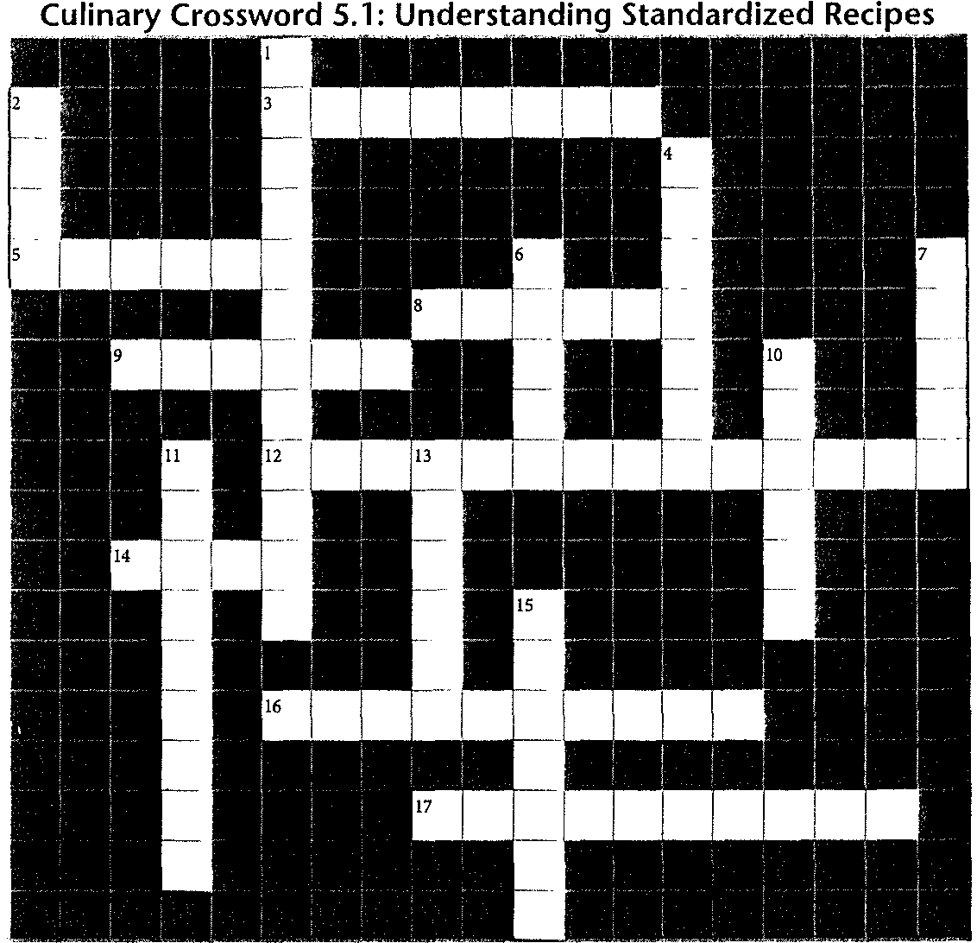

*Use the clues below to solve the puzzle, which contains vocabulary terms from Section 5.1.*

**Across**



3. What "tsp" stands for in the measurement

1 tsp .

5. Part of recipe that includes steps to make the dish

8. Measurement of the mass or heaviness of an ingredient

9. System of measurement using liters

12. Names and amounts ofitems needed in a recipe (2 words)

14. The "N" in the PRN method of reading recipes

16. Heaviness of the food container when using a scale (2 words)

17. Name of a culinary website that has recipes

***Answers are in the Crossword Solutions section.***

**106** _. *Introduction to Culinary Arts*

-

**Down**

1. Type of recipe designed to suit the needs of an individual kitchen

2. What "g" stands for in the measurement 1 g

4. Serving size for one person

6. Describes the measured output of a recipe

7. Describes the number of whole items needed in a recipe

10. Measurement of the space occupied by a solid,

liquid, or gas

11. Popular source of recipes, found in bookstores

13. Written record and steps needed to make a dish

15. The "p" in the PRN method of reading recipes

Name -----------------------Date



Chapter 5: Using Standardized Recipes

Converting Recipes

*Use this Study Guide to take notes during class* or *as you read the section in the textbook.*

Two Ways of Scaling Recipes

1. -------------------------------------------- Example:

2.



Example:

RCF=------------------------------ ----------------------

To Scale a Recipe by Changing Portion Size

1.

2.

3.



---

To Scale a Recipe Based on an Available Ingredient

1.

2. ----

,<;

3.

0

"0'

*E*

*g*c'

4.

0

JJ

c

0

**(CONTINUES ON NEXT PAGE)**

"' *Lab Resources & Study Guide l1fi"* 107

Study Guide 5.2 (coNTINUED)

Factors that Affect Scaled Recipes

1. Cooking Temperature:---------------------------

2. CooldngTime: ------------------------------

3.PanSize:

4.Seasonings: _



5. Limits on Scaling:-----------------------------

(CONTINUES ON NEXT PAGE)

108 */JI; Introduction to Culinary Arts*



Name: Date _

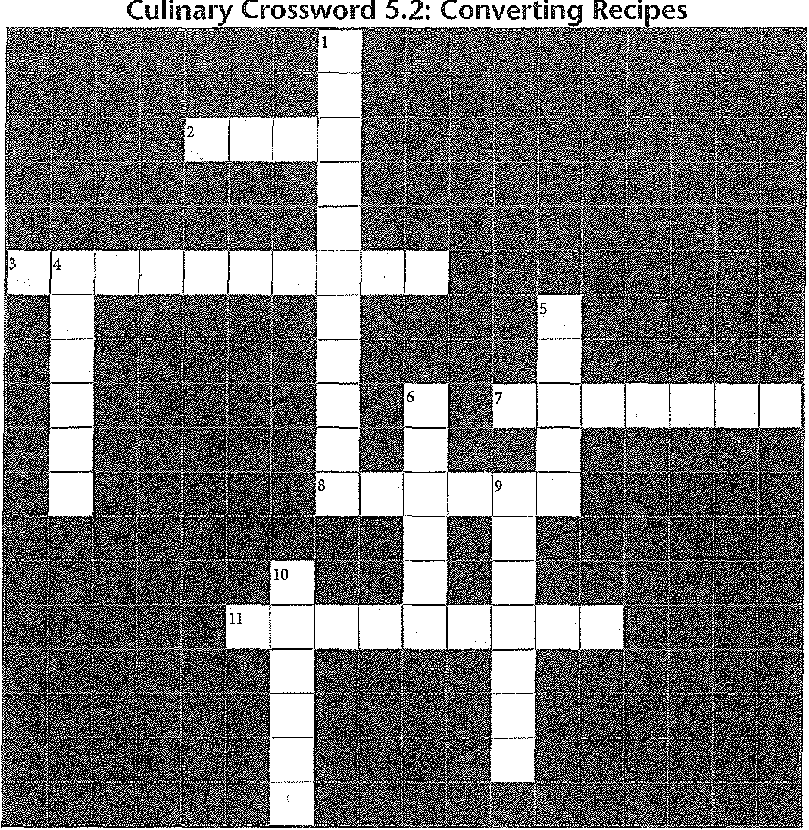

**Across**



*Use the clues below to solve the puzzle, which contains many vocabulary terms from Section 5.2.*

**Down**

2. You can scale a recipe up or

3. The "C" in RCF

7. 128 fluid ounces milk, scaled up with an RCF

of 2, means you need 2 of milk

8. The "R" in RCF

ll. The top number of a fraction

***Answers are in the Crossword Solutions sectioti.***

J. TI1e bottom number of a fraction

4. I cup of water, scaled down with an RCF of .5, means you need 4 of water

5. Change the amount of ingredients to get the needed yield

6. TI1e ''F" in RCF

9. You can scale a recipe by changing the

size

10. 2 pints of berries, scaled up with an RCF of 3, means yoneed 3 ofberries

*Lab Resources & Study Guide IJ;.,* 109



110 */11;. Introduction to Culinary Arts*



Name ------------- -------Date

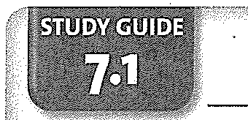

Mise en Place

Getting Re<!dy to Cook

*Use this Study Guide to take notes during class or as you read the section in the textbook.*

What is Involved in Mise en Place

1·-------------------------------------- ----------------

2. ------ ------------

3·---------------- ------------------------------------



4·-------------------------------- -- -------------- --

Three Initial Steps in Planning Your Work

1·----------- ---7---------- ---------- --------------------

2·------ ---- ------------------------------------ ----

3.

------------ ------------------ ----------------

Steps in Making a Timeline

1. -------------------------------- --------

2·------------------ ----------------------------------

·ID

!l

3.

·c

------



d

.5

..c,

0

4. -------------------------------- -------- --

Examples of Setting Priorities

1·-------- --------------------------------------

2.

ro

0

"

'C

w

c

0

ro

*.!:*

@

(CONTINUES ON NEXT PAGE)

*Lab Resources & Study Guide /it.* 127

Study Guide 7.1 ccoNTINUED)

Examples of Problem-Solving Strategies

1·---------------------------- --------------------------

2.

Examples of Work Sequencing



1·---------- ---------------- --------------------------

2.

3. -= -- ----------------------------------------

4·-------------------------------------------------- -------



Examples of Simplifying Work

1·-------------------- -------------------------- ------

2·------------------ ------------ ------------------ --

3·-------------------------- ----------------------------------

**(CONTINUES ON NEXT PAGE)**

128 */If;,. Introduction to Culinary Arts*

Study Guide 7.1 (CONTINUED)

Sample Items Needed at a Workstation

1.

2.

3.

4.

5.

6.

(CONTINUES ON NEXT PAGE)



*Lab Resources & Study Guide i/1.* 129

Name



**Across**

Dme

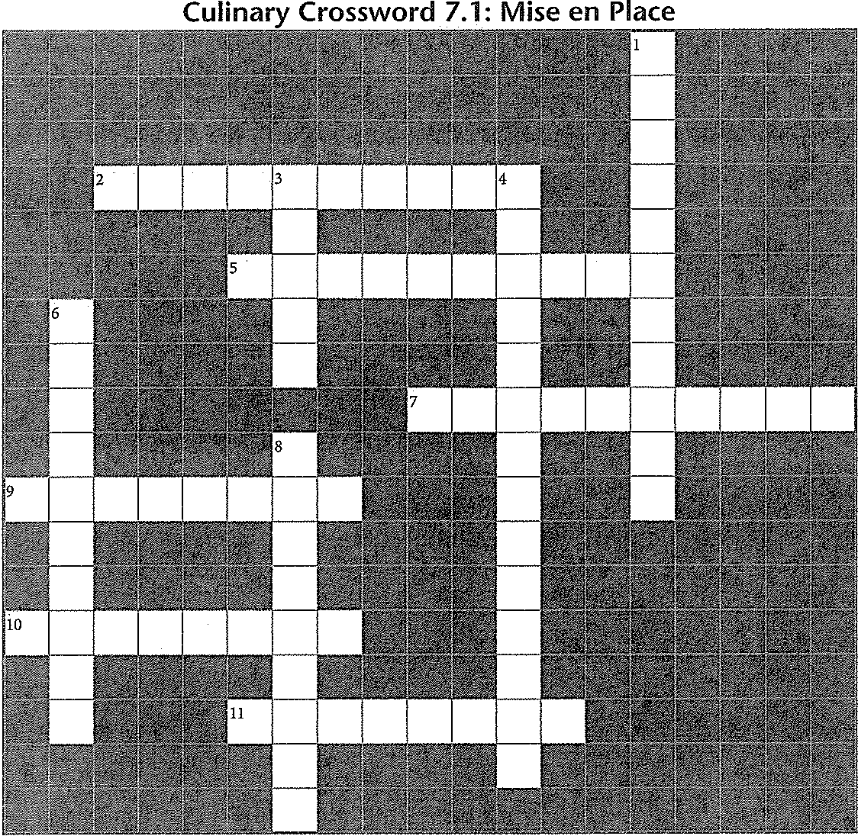

*Use the clues below to solve the puzzle, which contains many vocabulary terms from Section 7.1.*

**Down**



2. Skills and techniques used to complete the job

5. In mise en place, the food for which you will be responsible

7. Setting means deciding which tasks are

most important

9. Your completion time; when the dish you are preparing must be ready to serve

10. A schedule that tells you when certain tasks

must be completed

11. Putting ingredients, tools, and equipment in a logical order-for accomplishing your task

(2 words)

***Answers are in the Crossword Solutions section.***

130 */II» Introduction to Culinary Arts*

1. The place where you gather your tools and ingredients to prepare your mise en place

3. Small jobs that help you complete your mise en place assignment

4. Work is getting things done in the

fewest steps, the shortest time, with the least waste

6. Work means doing the right thing at

the right time

8. In mise en place, you prepare a written _

of what you have and what you need

Name ---------------------Date ---------

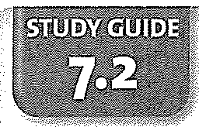

Chapter 7: Getting Ready to Cook

Learning to Work Together

*Use this Study Guide to take notes during class or as you read the section in the textbook.*



Elements of Effective Communication

1.

2.

3.

Tips for Receiving Criticism

1. _

2.

3.

4. _

-ci

•

!l Tips for Giving Criticism

:E!

"'

';t

":I:'

E0

1. --------------------------------------------------------

2.

"­

c

0

rn

**3.**

rn

"c'

"·1"'



*d*

.s

-"0

0 w"0 c

ro

*6:*

@

4.

**(CONTINUES ON NEXT PAGE)**

*Lab Resources & Study Guide f/JJ,.* 131

Study Guide 7.2 (CONTINUED)

Examples of Feedback

1.

2.

3.

4.



Examples of Courteous and Professional Behavior

1.

2.

3.

4.

**(CONTINUES ON NEXT PAGE)**



132 */iJ;. Introduction to Culinary Arts*

Name ----------------------Date

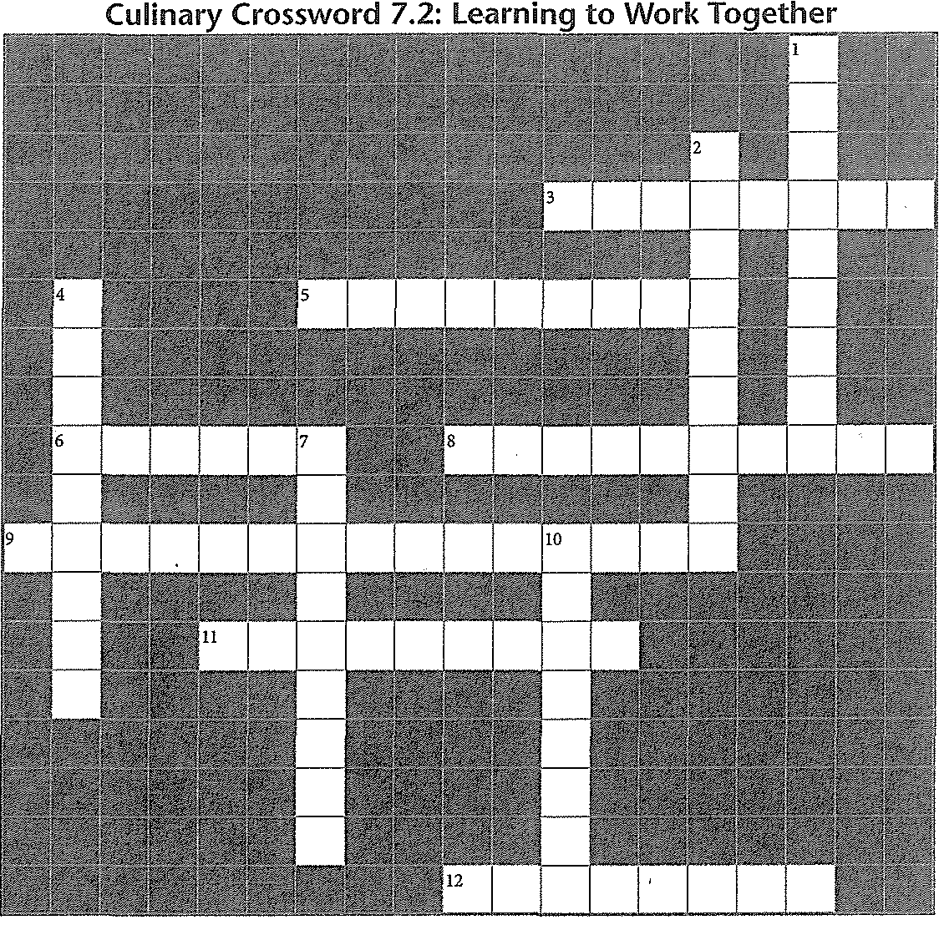

**Across**



*Use the clues below to solve the puzzle, which contains many vocabulary terms from Section 7.2.*

**Down**

3. Simple acts of make your work easier and more efficient

5. Feedback that tells you something was done

incorrectly

6. feedback is spoken

8. A form of positive feedback

9. The practice of maintaining standards for your work and your behavior

11. Asking is the second rule for effective

communication

12. A review of your work

***Answers are in the Crossword Solutions section.***

1. communication means more 'than simply talking

2. Effective points out mistakes and

possible improvements

4. feedback is not spoken

7. The first rule of effective communication

10. You must speak the of the kitchen to communicate effectively

*Lab Resources & Study Guide iJJJ;,* 133



134 • *Introduction to Culinary Arts*



Name --------------------Date ---------

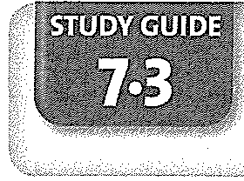

Food Presentation

*Use this Study Guide to take notes during class or as you read the section in the textbook.*

Basic Guidelines for Plate Presentation

1.

2.

3.



Examples of Basic Mise en Place for Service

1.

2.

3.

4.

5. -----------------------------

6.

Reasons for Portioning Food

1.

2.

3.

4.



Tools for Portioning

1.

2.

3.

4.

*E*"

..c,

0

ro

u

0

"0

w

c

0

ro

<1:

@

Keeping Foods at the Best Temperature

Hot Foods: Cold Foods:

Frozen Foods:--------------------------------------------

(CONTINUES ON NEXT PAGE)

*Lab Resources & Study Guide Jl;,.* 135

Study Guide 7.3 (CONTINUED)

Ways to Maintain Texture

1. ·-- ------------------ --------

2.

3.

4.

Ways to Present a Colorful Dish

1.

2.



3.

4·---------------------------------------- ---------------

5.

Ways to Shape and Arrange Food

1.

2.

3.

4.

5.



6.

(CONTINUES ON NEXT PAGE)

136 */J!I;;. Introduction to Culinary Arts*



138 *fJ/IJ;. Introduction to Culinary Arts*

"J:'

·g

•

u

a.

c

0

ro

*8'*

*w*

ro

c

:.i'

:0

0

0.

*J*

-"

..c,

0

ro

u

0

"0

"c'

0

E

ro

*8'*

@

**me vatt: _**

**Crossword 7.3: Food Presentation**

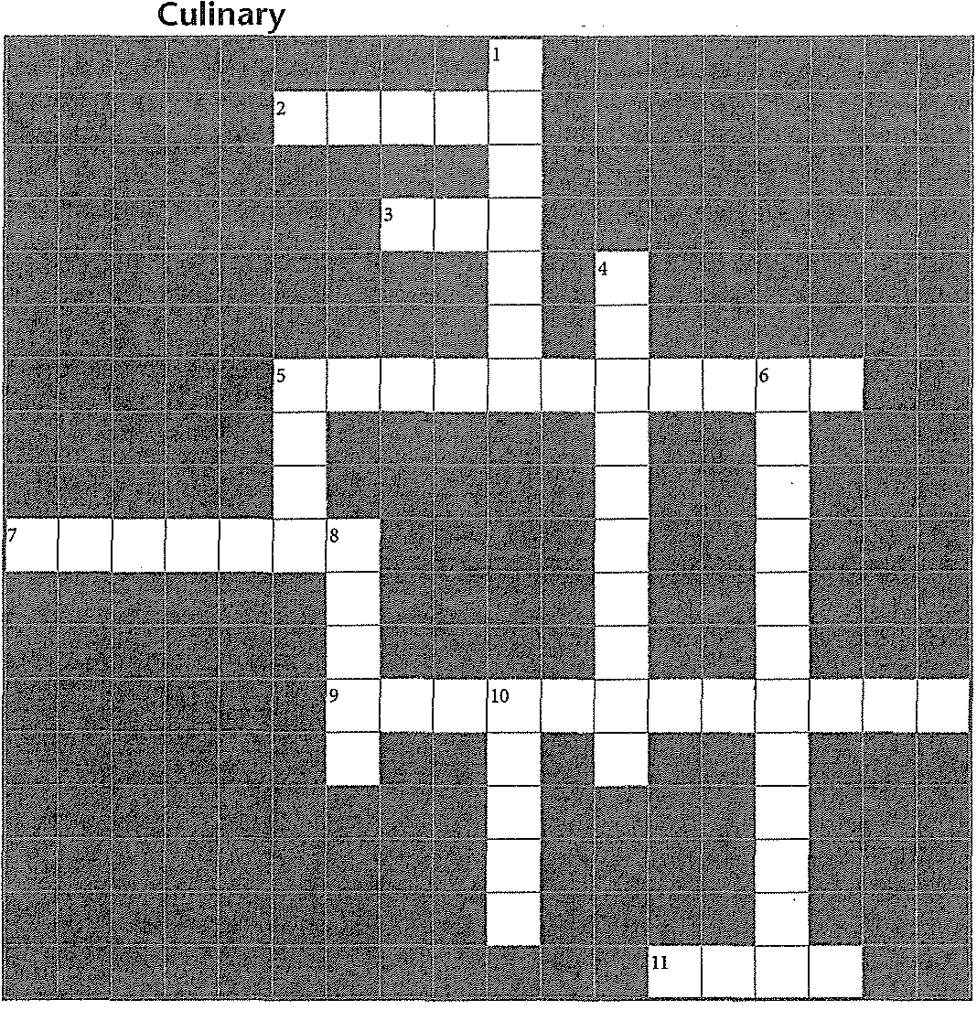

*Use the clues below to solve the puzzle, which contains many vocabulmy terms from Section 7.3.*

**:ross**

2. Tool you can use to serve the correc.t amount of a liquid food

3. foods should be served at least 135'

5. Type of arrangement that has equal numbers of items on either side of the plate

7. Cold foods should be served on plates

9. The way you put food onto a plate

.1. Use a to shape food attractively on a plate

***Answers are in the Crossword Solutions section.***

**Down**

1. Crackers add crunchy to a bowl of soup

4. Serving the correct amount of a particular food

5. The presentation should be facing up

on the plate

6. Type of arrangement that has unequal numbers of items on either side of the plate

8. Keeping plates neat, without any , is a

basic rule for good presentation

10. Tool you can use to serve a specific amount of ice cream

*Lab Resources & Study Guide fl;;,* 137