Using a Word Wall in the Secondary Classroom
Best Practice Idea

Definition: A word wall is a display area in the classroom devoted strictly to high-frequency vocabulary that will be used or is being used during the course of a particular unit of study.

Background Information:
- A word wall is most likely unfamiliar to most high school teachers or is something that may have been encountered in an elementary classroom.
- As part of a balanced literacy approach, word walls are being used in classrooms as a means of promoting vocabulary growth leading ultimately to improvement in literacy.
- Word walls are and extremely effective learning and teaching tools.

Pertinent Points About Word Walls:

- Words selected must be useful to students, usable by students and frequently used in the subject area.
- Select high-frequency words that are used in the context in which you expect the students to know them.
- Use the same display area throughout the semester for your word wall. Students, once used to the concept, will look for the wall.
- Consistency is important when presenting organizational ideas to a class. Refer to the display area as the ‘word wall’ as some students will remember this from their elementary experience.
- Do not overcrowd the word wall.
- Creatively display and organize words. High school students like visual stimuli as much as their elementary counterparts.
- Add words in manageable amounts (usually between 5 to 7 new words at a time…per week).
- Make word wall activities a regular and predictable part of the classroom routine.
- Word wall activities make for natural class openers or closers. The word wall activity should be only about 5 minutes in length unless incorporated with a larger activity.
- Use a variety of instructional activities to review words.

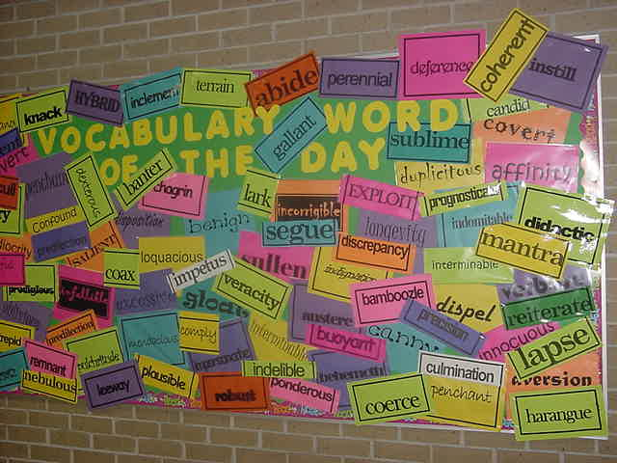
This word wall is in the school hallway to promote student awareness of the words they have studied this year. However, most word walls would not be cumulative. They should be posted around a unit or theme and then removed when the class moves on to other topics.
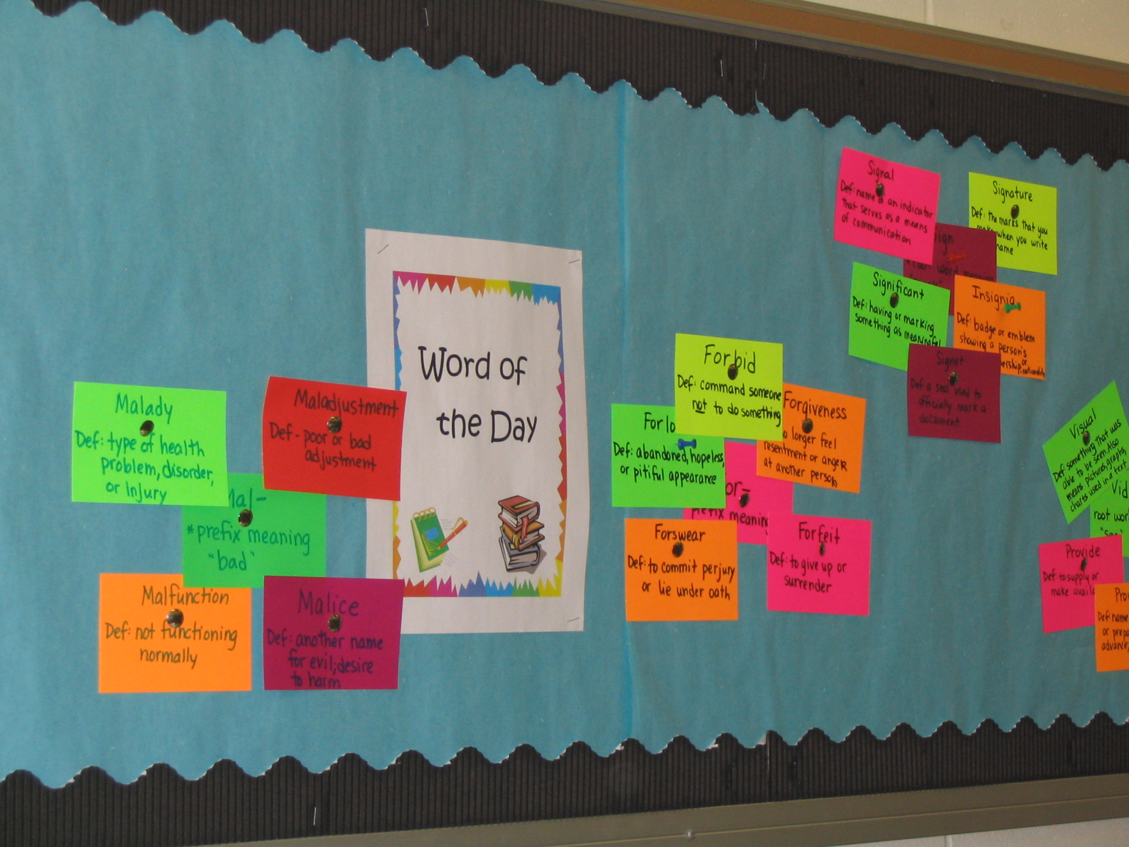
Word are clustered by commonalities on this Word Wall
.